LAB REPORS From 01 TO 13


Spring 2026
CSE-L Embeded Systems Lab
Submitted by: Naveed Ahmad
Registration number: 22PWCSE2165
Semester: 8th
Section: B

Student Signature: ______________

Submitted to:
Engr. Muhammad Shahzad
June 25, 2026

Department of Computer Systems Engineering
University of Engineering and Technology, Peshawar

LAB REPORT # 01



Spring 2026
CSE-L Embeded Systems Lab
Submitted by: Naveed Ahmad
Registration number: 22PWCSE2165
Semester: 8th

Section: B

Student Signature: ______________

Submitted to:
Engr. Muhammad Shahzad

(February 17, 2025)

Department of Computer Systems Engineering
University of Engineering and Technology, Peshawar

LAB 1
INTRODUCTION TO EMBEDDED SYSTEMS AND ARDUINO ENVIRONMENT
Objectives
- To understand the basic concept of embedded systems.
- To get familiar with the Arduino hardware and programming environment.
- To learn how to write and upload a simple Arduino program.
- To simulate an Arduino circuit using online Tinkercad software.
- To control an LED using digital output pins of Arduino.
Theory
An embedded system is a specialized computer system designed to perform a specific task within a larger system. It consists of a microcontroller or microprocessor along with software and hardware components.
Arduino is an open-source embedded development platform that includes:
- A microcontroller board (Arduino Uno)
- An Integrated Development Environment (IDE) for writing and uploading programs
In Arduino, digital pins can be configured as INPUT or OUTPUT. An LED can be controlled by setting the pin HIGH (ON) or LOW (OFF). The delay() function is used to pause program execution for a specified time in milliseconds.
Tinkercad is an online simulation tool that allows users to design and test Arduino circuits without physical hardware.
Circuit Diagram
- Software Used: Online Tinkercad
- Components:
  - Arduino Uno
  - Built-in LED (connected internally to Pin 13)

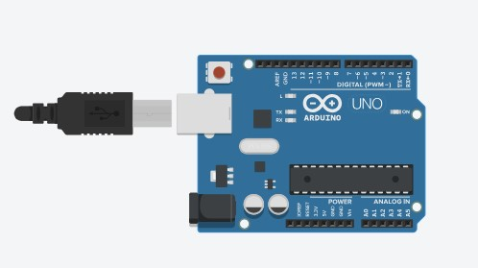
Algorithm
- Start the program.
- Initialize the built-in LED pin as OUTPUT.
- Turn the LED ON.
- Wait for 2000 milliseconds.
- Turn the LED OFF.
- Wait for 2000 milliseconds.
- Repeat the process continuously.
Source Code
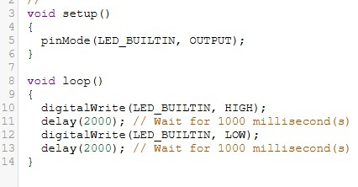
Procedure
- Open a web browser and go to the Tinkercad website.
- Create a new Arduino circuit project.
- Place an Arduino Uno board in the workspace.
- Use the built-in LED connected to pin 13.
- Write the LED blinking program in the code editor.
- Start the simulation.
- Observe the LED blinking behavior.
Results / Observations
- The built-in LED turned ON for 2 seconds and then turned OFF for 2 seconds.
- The LED continued blinking repeatedly throughout the simulation.
- The program executed successfully without any errors in Tinkercad.
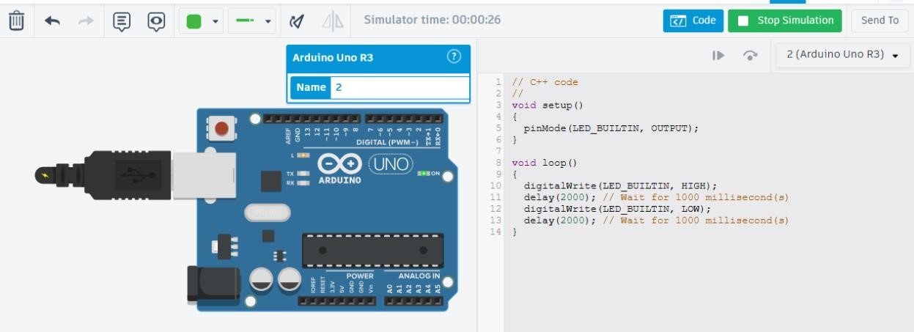

LAB NO 02
Lab Report: GPIO Programming & ATmega328P Architecture


Fall 2026

Embedded Systems Lab

Submitted by: Naveed Ahmad
Registration No.: 22PWCSE2165
Class Section: B

Student Signature: ______________

Submitted to:
Eng: Shahzad
Feb 25, 2026

Department of Computer Systems Engineering
University of Engineering and Technology, Peshawar

- Lab Title
GPIO Programming & ATmega328P Architecture
- Objectives:
- To understand the GPIO (General Purpose Input/Output) architecture of the ATmega328P.
- To learn register-level programming using Data Direction Registers (DDRx), Port Registers (PORTx), and Port Input Pins (PINx).
- To implement a hardware control loop where a pushbutton controls the state of an LED without using high-level Arduino libraries (like digitalWrite).

- Apparatus / Components:
- Arduino Uno (ATmega328P based)
- 1x LED (Red)
- 1x Resistor (220Ω - 1kΩ)
- 1x Pushbutton
- Connecting wires
- Tinkercad Simulation Environment

5. Theory (Concise):
The ATmega328P controls its pins through three primary 8-bit registers:
- DDRx (Data Direction Register): Configures a pin as either Input (0) or Output (1).
- PORTx (Port Register): Sets a pin High (1) or Low (0) when configured as output. If configured as input, writing a 1 enables the internal pull-up resistor.
- PINx (Port Input Pins): Used to read the logical value of an input pin.
In this lab, we use Port B (Pin 8-13) and Port D (Pin 0-7). Specifically, PB0 (Digital Pin 8) is used for the LED, and PD7 (Digital Pin 7) is used for the button.

- Circuit Diagram:
The circuit consists of:
  - LED Circuit: An LED connected to Digital Pin 8 (PB0) in series with a current-limiting resistor, terminating at Ground (GND).
  - Switch Circuit: A pushbutton connected between Digital Pin 7 (PD7) and Ground (GND). The code enables the internal pull-up resistor to ensure a stable "High" state when the button is not pressed.
Diagram:
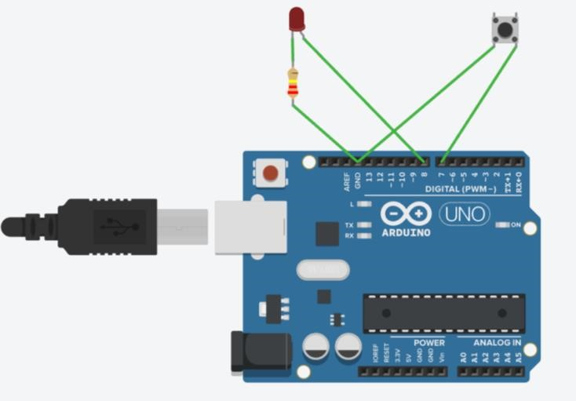

- Algorithm:
  - Initialize Hardware:
  - Set the bit corresponding to PB0 in DDRB to 1 (Output).
  - Clear the bit corresponding to PD7 in DDRD to 0 (Input).
  - Set the bit corresponding to PD7 in PORTD to 1 to enable the Internal Pull-up.
  - Main Loop:
  - Read the state of PIND bit 7.
  - If bit 7 is 0 (Button pressed/grounded):
  - Set PORTB bit 0 to 1 (Turn LED ON).
  - Else (Button not pressed):
  - Clear PORTB bit 0 to 0 (Turn LED OFF).
  - Repeat indefinitely
- Code and Simulation on Thinkercad:
Code:
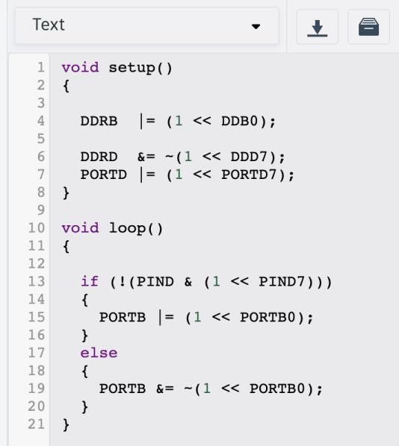

Simulation:
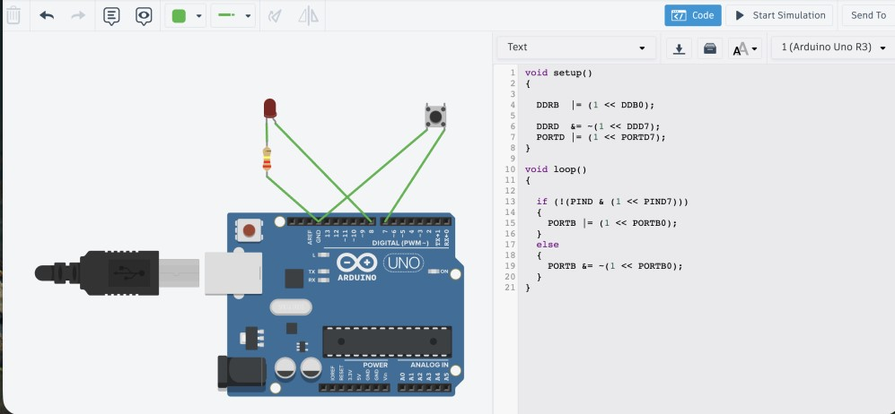

- Procedure
  - Access the Tinkercad circuit simulator.
  - Place an Arduino Uno on the workspace.

  - Connect the cathode of the LED to GND and the anode to Digital Pin 8 via a resistor.
  - Connect one terminal of the pushbutton to GND and the other to Digital Pin 7.
  - Open the Code editor, switch to Text mode, and enter the register-level C code provided above.
  - Click Start Simulation.
  - Interact with the pushbutton and observe the LED response.

- Observations & Results
    - Initial State: When the simulation starts, the LED remains OFF. This is because the internal pull-up resistor keeps PD7 at a logic HIGH (1).
    - Button Pressed: When the button is clicked, PD7 is shorted to Ground. The if condition !(PIND & (1 << PIND7)) becomes true, and the LED on PB0 turns ON.
    - Button Released: The LED turns OFF immediately upon release.
    - Result: The logic correctly identifies the active-low signal from the button to toggle the output.

- Conclusion
This lab successfully demonstrated GPIO manipulation using direct register access. This method is more efficient than standard Arduino functions as it reduces CPU overhead and allows for simultaneous pin manipulation. We confirmed that the DDRx register correctly handles direction, and PORTx/PINx registers effectively manage state and input sensing.

LAB # 03
Interrupts an Advanced I/O



Spring 2026 CSE-420L Embedded Systems Lab

Submitted by: Naveed Ahmad
Registration No.: 22PWCSE2165
Class Section: B

“On my honor, as student at University of Engineering and Technology, I have neither given nor received unauthorized assistance on this academic work.”

Submitted to:
Engr. Muhammad Shahzad
March 5th, 2026

Department of Computer Systems Engineering
University of Engineering and Technology, Peshawar

Objective:
- To understand the concept of polling and interrupts in microcontrollers.
- To study different types of interrupts.
- To analyze interrupt handling in the ATmega328P microcontroller.
- To learn the role of important interrupt registers and advanced I/O operations.
Theory:
Polling:
Polling is a technique where the microcontroller continuously checks the status of an input device to determine whether an event has occurred.
In polling, the processor repeatedly reads the status of the device in a loop. This method consumes more CPU time because the processor must constantly check the device even when no event occurs.
Interrupts are preferred over polling because they allow the processor to perform other tasks and respond only when an event happens.
Types of Interrupts:
Interrupts can be classified into the following types:
1. Hardware Interrupt:
A hardware interrupt is generated by an external hardware device connected to the microcontroller.
Example:
- Push button press
- Sensor signal
These interrupts are triggered through external interrupt pins such as INT0 and INT1 in the ATmega328P.
2. Software Interrupt:
A software interrupt is generated by a program instruction during program execution.
Example:
- System calls
- Special instructions that request processor attention.
- Internal Interrupt:
Internal interrupts are generated by internal peripherals of the microcontroller.
Examples:
  - Timer overflow
  - ADC conversion complete • USART transmission complete
- External Interrupt:
External interrupts are generated by signals coming from outside the microcontroller.
Example:
  - A push button connected to INT0 pin triggering an interrupt.
Internal Architecture of ATmega328P:
The ATmega328P is an 8-bit microcontroller based on the AVR architecture.
Main components of its architecture include:
  - CPU Core
  - Flash Memory (program storage) • SRAM (temporary data storage)
  - EEPROM (non-volatile memory)
  - I/O Ports
  - Timers/Counters
  - Interrupt Unit
The interrupt controller monitors interrupt signals and transfers control to the Interrupt Service Routine (ISR) when an interrupt occurs.
Important Registers:
- SREG (Status Register)
The Status Register (SREG) stores the status of arithmetic operations and processor state.
Important bit:
• Global Interrupt Enable (I-bit) which enables or disables interrupts in the system.
- EIMSK (External Interrupt Mask Register):
The External Interrupt Mask Register enables or disables external interrupts.
Example:
• Setting the INT0 bit enables interrupt from pin INT0.
- EICRA (External Interrupt Control Register A):
The EICRA register controls how external interrupts are triggered.
It defines the interrupt trigger type such as:
    - Low level
    - Logical change
    - Falling edge
    - Rising edge
- TIMSK (Timer Interrupt Mask Register):
The Timer Interrupt Mask Register enables or disables timer-related interrupts such as:
    - Timer overflow interrupt
    - Output compare interrupt Interrupt Execution Steps:
When an interrupt occurs in the ATmega328P, the following steps take place:
  - The microcontroller finishes executing the current instruction.
  - The program counter (PC) address is saved onto the stack.
  - The Global Interrupt Flag in the SREG register is cleared.
  - The processor jumps to the Interrupt Service Routine (ISR) address.
  - The ISR executes the required task.
  - After completion, the RET I instruction returns the program to the main execution.
Components / Registers Used:
The following registers and components are used in this experiment:
Register | Function
DDRB | Configures PORTB pins as input or output
PORTB | Used to send output signals (e.g., LED control)
EIMSK | Enables or disables external interrupts
EICRA | Selects the interrupt triggering condition
SREG | Contains the global interrupt enable flag
Code:
#include <avr/io.h> #include<avr/interrupt.h> volatile uint8_t count = 0;

ISR(TIMER0_OVF_vect)
{
count++;

if(count >= 31)
{
PORTB ^= (1 << PB0); count=0;
}
}
int main()
{
DDRB |= (1 << PB0);
TCCR0B |= (1 << CS02)|(1 << CS00); //Clock select: 1024 Prescaler TIMSK0 |= (1 << TOIE0); //enable timer overflow interrupt sei(); while (1)
{
}
}
Circuit Diagram:
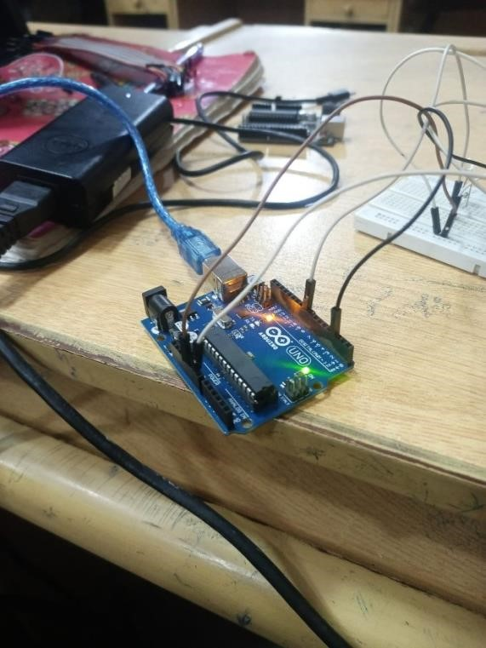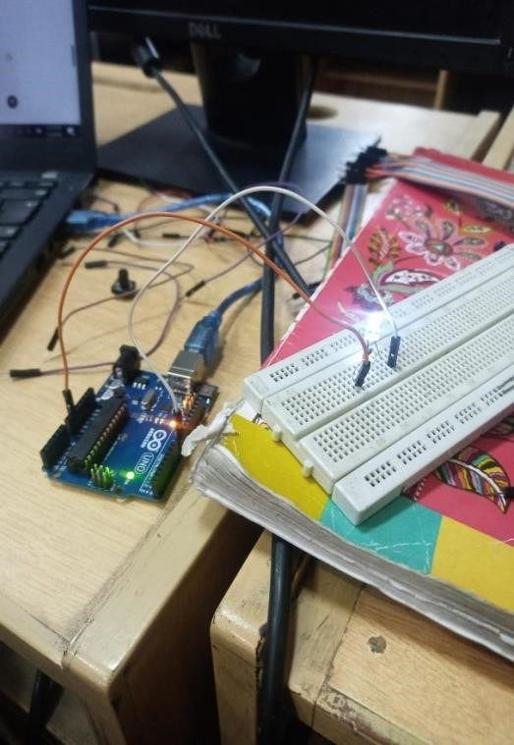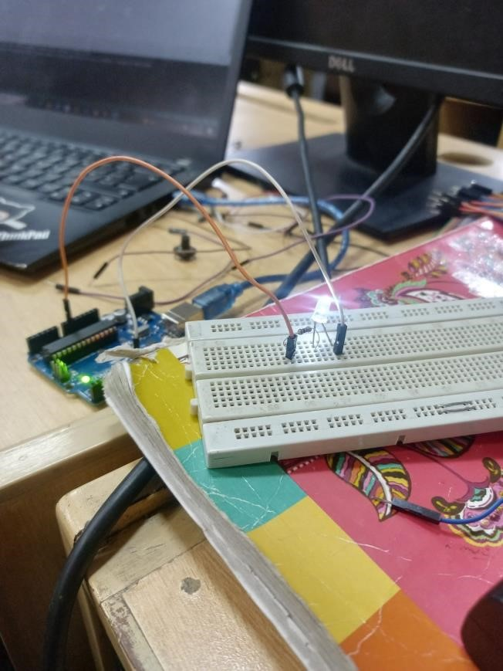

Lab Report No 04

Performance Analysis of Embedded Programs



Spring 2026
CSE-420L Embedded Systems LAB

Submitted By: Naveed Ahmad
RegistrationNo:22PWCSE2154

Section: B

“On my honor, as student of University of Engineering and Technology, I have neither given nor received unauthorized assistance on this academic work”

Submitted to:

Engr. Muhammad Shahzad
March 17, 2026

Department of Computer Systems Engineering
University of Engineering and Technology Peshawar

Title: Performance Analysis of Embedded Programs
Latency:
Latency is the time delay between giving a command and the system starting to respond.

Example:
In Arduino, the time between sending a signal to a pin and the pin actually changing state is called latency.

Latency = Response delay time

Throughput:
Throughput is the amount of work or number of operations completed in a given time.
Example:
How many times Arduino can toggle a pin in one second.

Throughput = Number of operations per unit time

Objective:
- To measure the execution time of pin toggling in Arduino Uno.
- To compare the speed of digitalWrite() function and Direct Register Access (PORTB).
- To understand how low-level register manipulation improves performance in embedded systems.

Apparatus:

- Arduino Uno R3
- USB Cable
- Computer / Laptop
- Arduino IDE
- LED (optional)
Theory:

Arduino boards use a microcontroller to control input and output pins. The execution time of a command shows how long the microcontroller takes to perform an operation.

1. Using digitalWrite()

digitalWrite() is a high-level Arduino function used to set a pin HIGH or LOW.

Example:
digitalWrite(13, HIGH); digitalWrite(13, LOW);

Advantages:
- Easy to use
- Portable across boards
Disadvantages:
- Slower because it performs multiple internal operations such as:
o Checking pin mapping o Setting registers internally

2. Using Direct Register Access
In this method we directly manipulate hardware registers of the microcontroller.
Example registers:
- DDRB → Data Direction Register
- PORTB → Output Register

Example:

PORTB |= (1 << PORTB5);
PORTB &= ~(1 << PORTB5);
Advantages:

- Much faster execution
- Less overhead
Disadvantages:

- Harder to understand
- Hardware dependent

Execution Time Measurement
The function micros() is used to measure time in microseconds.
Example:
startTime = micros();

After executing code:

executionTime = endTime - startTime;

Circuit diagram Experiment 1:
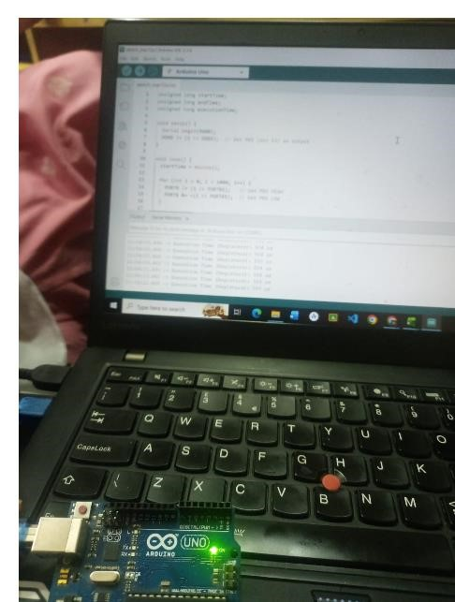

Connections:

• Arduino Pin 13 → Resistor → LED → GND

Note: Arduino Uno also has a built-in LED on pin 13, so external LED is optional.
Experiment 1: Using digitalWrite() Algorithm:
- Start the program.
- Initialize serial communication at 9600 baud.
- Set pin 13 as OUTPUT.
- Record start time using micros().
- Run a loop 1000 times.
- Set pin HIGH using digitalWrite().
- Set pin LOW using digitalWrite().
- Record end time using micros().
- Calculate execution time.
- Print execution time on Serial Monitor.
- Repeat after 2 seconds.

Source code:
unsigned long startTime; unsigned long endTime;
unsigned long executionTime;

void setup() { Serial.begin(9600); pinMode(13, OUTPUT);
}

void loop() { startTime = micros();

for (int i = 0; i < 1000; i++) { digitalWrite(13, HIGH); digitalWrite(13, LOW);
}
endTime = micros();
executionTime = endTime - startTime;

Serial.print("Execution Time (digitalWrite): ");
Serial.print(executionTime);
Serial.println(" us");

delay(2000);
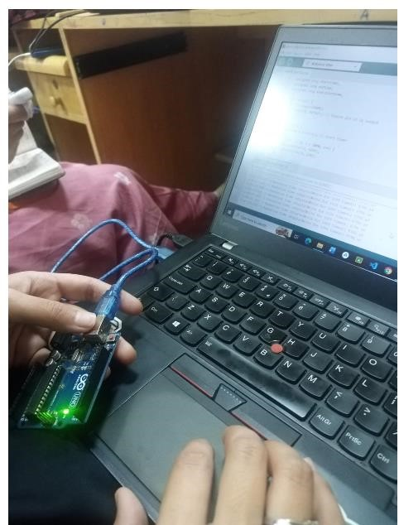}
Experiment 2: Using Direct Register Access Algorithm:
- Start the program.
- Initialize Serial communication.
- Configure Pin 13 (PB5) as OUTPUT using DDRB register.
- Record start time.
- Run loop 1000 times.
- Set pin HIGH using PORTB.
- Set pin LOW using PORTB.
- Record end time.
- Calculate execution time.
- Display the result on Serial Monitor.
- Repeat after delay

Source code:
// Experiment 2: Execution time using Direct Register Access

unsigned long startTime; unsigned long endTime; unsigned long executionTime;

void setup() {
Serial.begin(9600);
DDRB |= (1 << DDB5); // Set pin 13 (PB5) as OUTPUT
}

void loop() {
startTime = micros();

for (int i = 0; i < 1000; i++) {
PORTB |= (1 << PORTB5); // Set pin HIGH
PORTB &= ~(1 << PORTB5); // Set pin LOW
}

endTime = micros(); executionTime = endTime - startTime;

Serial.print("Execution Time (Registers): ");
Serial.print(executionTime); Serial.println(" us");

delay(2000);
}
Procedure:

- Connect Arduino Uno to the computer using a USB cable.
- Open Arduino IDE.
- Write the first program using digitalWrite().
- Upload the code to Arduino.
- Open Serial Monitor.
- Observe the execution time results.
- Now write the second program using Direct Register Access.
- Upload the code again.
- Observe the execution time results.
- Compare both results.

LAB 05

“Hardware Timers”

Spring 2026
Embedded Systems Lab
Submitted by: Naveed Ahmad
Registration No.: 22PWCSE2165
Class Section:B

Student Signature: ______________
Submitted to:
Engr. Muhammad Shahzad
April 22, 2026
Department of Computer Systems Engineering
University of Engineering and Technology, Peshawar
Lab : 05

“Hardware Timers”
Timers:
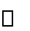
- Crystal Oscillator / Pulse Generator • Quartz (16MHz)
ATmega328p
- Timers increment automatically with every clock tick
- Like 255 for 8-bit , 65535 for 16 bit
- Generate delays
- Measuring time Intervals
- Producing PWM Signals
- Triggering interrupts at precise intervals Time = timer count * prescaler / clock frequency
e-g:
Timer 0 = 8 bits -> millis , micros , delays
Timer 1 = 16 bits -> Servo libraries , High Resolution PWM
Timer 2 = 8 bits -> Tone Generation
Prescaler:
A numerical frequency divider placed before the timer , It extends the range of the timer so u can measure longer intervals or generate slower frequencies without using huge registers.
Ex:
System Clock = 16 MHz
Prescaler 1 = Timer tick after every 62.5 ns
Prescaler 8 = Timer tick after every 0.5 ns
Prescaler 64 = Timer tick after every 4 ns
Prescaler 1024 = Timer tick after every 64 ns
Without the prescaler the timer will overflow in 4ms with prescaler 1024
Max interval = 65536 * 64 micro S
= 4.2 Sec
TASK 1 :
LED blinks using hardware timers
Void setup(){
Pinmode(13,OUTPUT);
TCCR1A = 0;
TCCR1B = 0;
TCCR1B|= (1<<CS12) (1<<CS10);
}
Void loop(){
If (TCNT1>=15625){ TCNT1=0;
digitalwrite(13,!digitalRead(13));
}
}

• Setting PreScaler:
CS12 = 1 CS11 = 0
CS10 = 1
001 divide by 1
010 divide by 8
011 divide by 64
- divide by 256
- divide by 1024 Task picture :
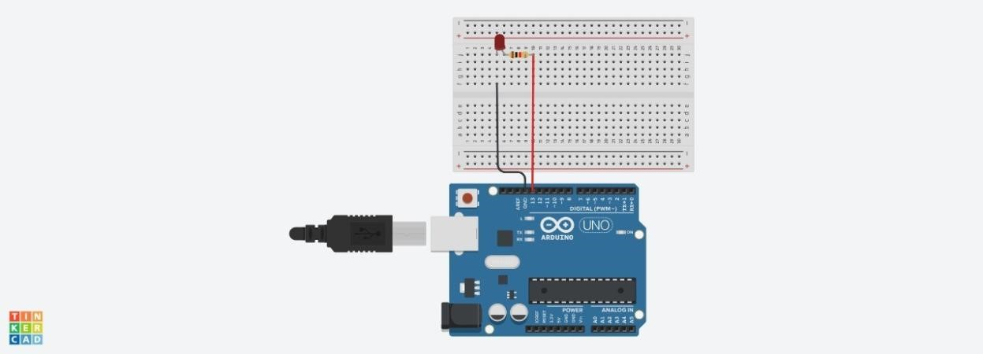
Task 2 :
CODE :
void setup() {
pinMode(13, OUTPUT);
TCCR1A = 0;
TCCR1B = 0;
TCCR1B |= (1 << WGM12); // Enable CTC mode
OCR1A = 15624; // Compare value
TCCR1B |= (1 << CS12) | (1 << CS10); // Prescaler = 1024
}
void loop() { if (TIFR1 & (1 << OCF1A)) { // Check
compare match flag TIFR1 |= (1 << OCF1A); // Clear flag digitalWrite(13, !digitalRead(13)); // Toggle LED } }
Task picture:
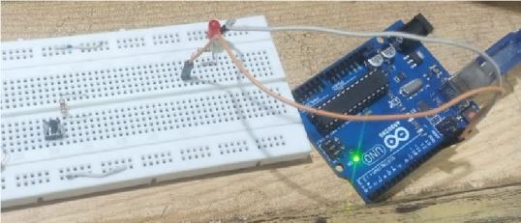

Task 3 :
Code:
const int LED_PIN = 9;
volatile int brightness = 0; volatile int step = 10; volatile int tickCount = 0; const int TICKS_PER_STEP = 6;
ISR(TIMER2_COMPA_vect) {
tickCount++; if (tickCount < TICKS_PER_STEP) return; tickCount = 0; brightness += step;
if (brightness >= 999) { brightness = 999; step
= -10;
} else if (brightness <= 0) { brightness = 0; step = 10;
}
OCR1A = brightness;
}
void setup() {
pinMode(LED_PIN, OUTPUT);
TCCR1A = (1 << COM1A1) | (1 << WGM11);
TCCR1B = (1 << WGM13) | (1 << WGM12) | (1 << CS11);
ICR1 = 999;
OCR1A = 0;
TCCR2A = (1 << WGM21);
TCCR2B = (1 << CS22) | (1 << CS21) | (1 << CS20);
OCR2A = 255; TIMSK2 = (1 << OCIE2A);
sei();
}
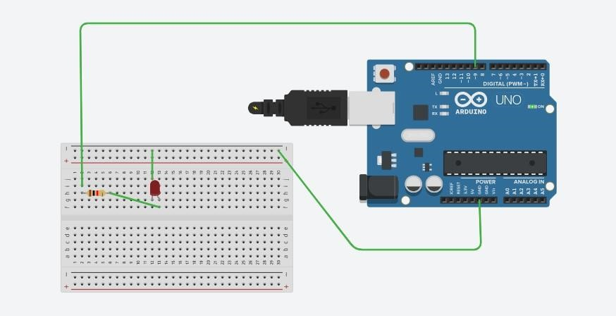

void loop() {

}

Conclusion:
Hardware timers on the ATmega328p enable precise, CPU-independent time control through configurable prescalers and timer registers, allowing applications ranging from simple LED blinking with TCNT1 polling, to accurate CTC-mode compare interrupts, to smooth PWM-driven LED breathing — all without relying on software delays.

LAB 06 Analogue to Digital Conversion (ADC)



Spring 2026
CSE-420L Embedded Systems LAB

Submitted By: Naveed Ahmad
Registration No: 22PWCSE2165

Section: B

“On my honor, as student of University of Engineering and Technology, I have neither given nor received unauthorized assistance on this academic work”

Submitted to:

Engr. Muhammad Shahzad
May 3, 2026

Department of Computer Systems Engineering

University of Engineering and Technology Peshawar
ADC:
ADC is the process of converting a continuous physical quantity (analog signal) into a digital representation (binary numbers). This process is governed by the Nyquist-Shannon Sampling Theorem, which states that to perfectly reconstruct an analog signal, you must sample it at a rate f_s at least twice as high as the highest frequency component present in the signal fmax

f_s > 2 fmax
If this condition is not met, aliasing occurs, where high-frequency components appear as lowfrequency artifacts in the sampled data.
Stages of Conversion
The conversion process typically involves three distinct stages:
- Sampling: Converting a continuous-time signal into a discrete-time signal by taking periodic "snapshots" of the amplitude at specific time intervals T_s = 1/f_s.
- Quantization: Mapping the infinite range of possible analog amplitudes to a finite set of discrete levels. Each level is determined by the ADC's resolution.
- Encoding: Assigning a unique binary code to each quantized level.
Common ADC Architectures
Depending on your lab equipment, you are likely using one of these common topologies:
- Flash ADC: Extremely fast but hardware-intensive (uses 2^n - 1 comparators). Best for high-speed applications.
- Successive Approximation Register (SAR) ADC: A balanced approach that uses a binary search algorithm to arrive at the digital value. It is the most common architecture for general-purpose microcontrollers.
- Delta-Sigma ADC: Uses oversampling and noise shaping. It provides very high resolution and is commonly used in high-fidelity audio applications.
TASK:1
Read Anaolgue value using potentiometer and display ADC value on serial monitor.
CODE:
#include <avr/io.h>
#include <stdio.h>
#include <util/delay.h>

// Initialize USART for Serial communication at 9600 baud void USART_init(void) {
UBRR0H = 0;
UBRR0L = 103; // For 16MHz clock and 9600 baud
UCSR0B = (1 << TXEN0); // Enable Transmitter
UCSR0C = (1 << UCSZ01) | (1 << UCSZ00); // 8-bit data
}

// Send a character over USART void USART_transmit(char data) { while (!(UCSR0A & (1 << UDRE0)));
UDR0 = data;
}

// Initialize ADC void ADC_init(void) {
// AREF = AVcc
ADMUX = (1 << REFS0);
// Enable ADC, set Prescaler to 128 (16MHz/128 = 125kHz)
ADCSRA = (1 << ADEN) | (1 << ADPS2) | (1 << ADPS1) | (1 << ADPS0);
}

// Read ADC value uint16_t ADC_read(uint8_t ch) {
ADMUX &= 0xF0; // Clear previous channel
ADMUX |= ch; // Select new channel ADCSRA |= (1 << ADSC); // Start conversion while (ADCSRA & (1 << ADSC)); // Wait for conversion to complete return ADC; // Return 10-bit result
}

int main(void) {
USART_init();
ADC_init();

char buffer[10];

while (1) { uint16_t adc_val = ADC_read(0);

// Convert integer to string and transmit sprintf(buffer, "%d\r\n", adc_val); for(int i = 0; buffer[i] != '\0'; i++) {
USART_transmit(buffer[i]);
}

_delay_ms(500);
}
}
OUTPUT:
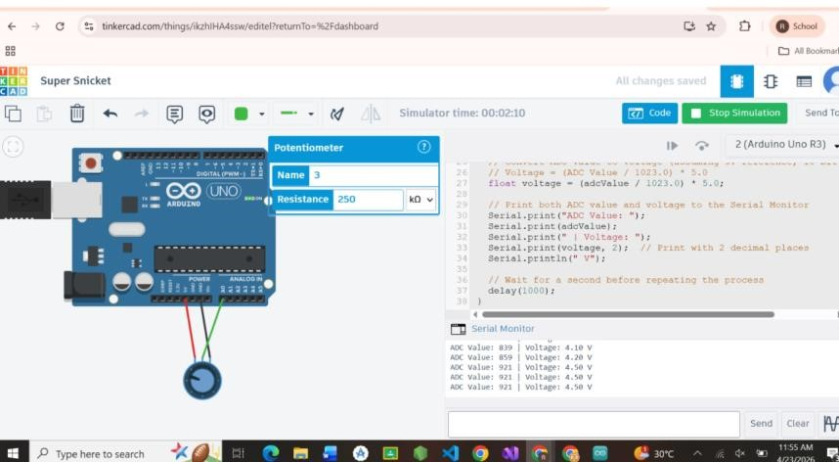
TASK:2
Control LED brightness based on sensor i/p(use hardware registers)
CODE:
#include <avr/io.h>

// Initialize ADC for 10-bit resolution void ADC_init(void) {
// REFS0: Set Reference Voltage to AVcc (5V)
// The MUX bits are left at 0 to select ADC Channel 0 (PC0)
ADMUX = (1 << REFS0);

// ADEN: Enable ADC
// ADPS2, ADPS1, ADPS0: Set Prescaler to 128 (16MHz/128 = 125kHz ADC clock)
ADCSRA = (1 << ADEN) | (1 << ADPS2) | (1 << ADPS1) | (1 << ADPS0); }

// Read from the currently selected ADC channel uint16_t ADC_read(void) {
ADCSRA |= (1 << ADSC); // Set ADSC bit to start the conversion while (ADCSRA & (1 << ADSC)); // Wait until ADSC clears (conversion complete) return ADC; // Return the 10-bit ADC result
}

// Initialize Timer1 for 10-bit Fast PWM void PWM_init(void) {
// Set PB1 (Pin 9 on Arduino Uno) as an output pin
DDRB |= (1 << PB1);

// TCCR1A Settings:
// COM1A1 = 1, COM1A0 = 0: Clear OC1A on Compare Match, set OC1A at BOTTOM (Noninverting mode)
// WGM11 = 1, WGM10 = 1: Fast PWM, 10-bit mode
TCCR1A = (1 << COM1A1) | (1 << WGM11) | (1 << WGM10);

// TCCR1B Settings:
// WGM12 = 1: Completes the 10-bit Fast PWM mode selection
// CS11 = 1, CS10 = 1: Set clock prescaler to 64 (Yields a PWM frequency of ~244 Hz at 16MHz) TCCR1B = (1 << WGM12) | (1 << CS11) | (1 << CS10);

// Initialize Output Compare Register (Duty Cycle) to 0
OCR1A = 0;
}

int main(void) { ADC_init();
PWM_init();

while (1) {
// 1. Read the 10-bit value from the sensor (0 to 1023) uint16_t sensor_val = ADC_read();

// 2. Write the 10-bit value directly to Timer1's Compare Match register
// A value of 0 means 0% duty cycle (LED off)
// A value of 1023 means 100% duty cycle (LED fully on)
OCR1A = sensor_val;
}
}
OUTPUT:

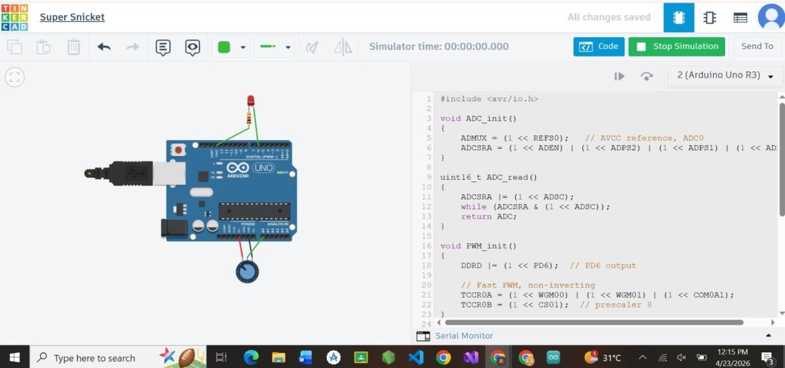

Conclusion:
This lab successfully demonstrated the integration of Analoge-to-Digital Conversion (ADC) and Pulse
Width Modulation (PWM) using AVR hardware registers. By interfacing a potentiometer with the ATmega328P, we effectively transformed continuous analog signals into 10-bit digital values, verifying the process through serial monitoring. Furthermore, applying these digital values to control LED brightness showcased a practical application of data acquisition and hardware control, reinforcing the importance of sampling rates, resolution, and register-level programming in embedded systems design.

Lab Report No 7
Digital to Analogue Converters


Spring 2026
CSE-420L Embedded Systems Lab

Submitted By: Naveed Ahmad
Registration No: 22PWCSE2165
Section: B

“On my honor, as student of University of Engineering and Technology, I have neither given nor received unauthorized assistance on this academic work”

Submitted to:
Engr. Muhammad Shahzad
May 3, 2026

Department of Computer Systems Engineering
University of Engineering and Technology Peshawar

- Objective
The objective of this lab is to understand the working principle of Digital-to-Analogue Converters (DAC), explore different types of DAC implementations, and implement DAC functionality on Arduino UNO using PWM (Pulse Width Modulation) since Arduino UNO does not have a built-in DAC. The lab also covers how hardware registers are used to configure and control DAC and PWM on microcontrollers
- Components Required
  - Arduino UNO — Main microcontroller board (ATmega328P)
  - MCP4725 — External I2C DAC module (12-bit resolution)
  - LED — For observing analogue output (brightness variation)
  - LDR (Light Dependent Resistor) — As sensor input for Task 02
  - Resistors — 10kΩ (pull-down for LDR), 220Ω (current limiting for LED)
  - Jumper Wires — For circuit connections on breadboard
  - Breadboard — For prototyping the circuit
  - USB Cable — For programming and powering the Arduino
- Theory
3.1 Digital-to-Analogue Converter (DAC)
A Digital-to-Analogue Converter (DAC) is a device that converts a digital binary value into a proportional analogue voltage. DACs are essential in embedded systems whenever a microcontroller needs to produce a continuously variable output — for example, to drive a speaker, control motor speed, or set a reference voltage for a sensor. The output voltage of a DAC is determined by the following formula:

Vout = Vref × (Digital Value / 2ⁿ)
Where Vref is the reference voltage, Digital Value is the binary input, and n is the number of resolution bits. For example, if the digital value is 128 with an 8-bit DAC and Vref = 5V, then Vout = 5 × (128/256) = 2.5V — exactly half the reference voltage.

3.2 DAC on Arduino UNO (PWM Method)
The Arduino UNO (ATmega328P) does not have a built-in hardware DAC. To simulate an analogue output, it uses PWM (Pulse Width Modulation). PWM works by switching a digital output on and off at a fixed frequency, varying the duty cycle (the percentage of time the signal is HIGH). When passed through a low-pass RC filter, a PWM signal approximates an analogue voltage proportional to the duty cycle. The key hardware registers used for PWM on the ATmega328P are:

  - TCCR0A — Timer/Counter Control Register A: configures the timer mode (Fast PWM or Phase Correct) and the compare output mode.
  - TCCR0B — Timer/Counter Control Register B: sets the clock prescaler which determines PWM frequency.
  - OCR0A / OCR0B — Output Compare Registers: hold the duty cycle value (0–255 for 8-bit). The timer compares this value to its counter to determine when to toggle the output.

3.3 DAC Using External IC: MCP4725
For true analogue output, the MCP4725 is a 12-bit external DAC module that communicates with the Arduino via the I2C protocol. It provides a genuine continuous analogue voltage output (0 to Vcc) with 4096 steps of resolution. This is used when precise, smooth analogue signals are needed, such as generating waveforms or driving analogue sensor inputs for testing.

3.4 Microcontrollers with Built-in DAC
Several modern microcontrollers include hardware DAC modules natively, eliminating the need for PWM approximation or external ICs:
  - ESP32 — 2-channel 8-bit DAC on GPIO25 and GPIO26
  - STM32 (selected variants) — 12-bit DAC with DMA support
  - PIC (selected models) — 8-bit or 10-bit DAC on specific modules
These microcontrollers use dedicated hardware registers to configure and control the DAC output. The key registers are:
  - DAC_CR — Control Register: enables the DAC channel and selects the trigger source.
  - DAC_DR — Data Register: stores the digital value to be converted to analogue output.
  - DAC_SR — Status Register: indicates the current state of the DAC conversion process.

3.5 ADC vs DAC Comparison

Feature | ADC (Analogue-to-Digital) | DAC (Digital-to-Analogue)
Function | Converts analogue signal → digital | Converts digital value →  analogue signal
Input | Analogue voltage | Binary / digital number
Output | Binary digital value | Analogue voltage

Primary Use | Reading sensors (temperature, light) | Driving actuators, audio, motor control
Arduino UNO | 6 channels, 10-bit (A0–A5) | No built-in DAC — uses PWM instead
Resolution Example | 1024 steps (10-bit) | 256 steps (8-bit) / 4096  (MCP4725)

TASK 01: Generate PWM signal
Register used must be TCCR0 , TCCR0A , TCCR0B
Code:
// Task 01: Generate PWM signal using hardware registers // PWM on PD6 (Arduino Pin 5) using Timer0

void setup() {
// Set PD6 as output
DDRD |= (1 << PD6);

// Configure Timer0 for Fast PWM, non-inverting mode
// WGM00 = 1, WGM01 = 1 => Fast PWM
// COM0A1 = 1 => Non-inverting output on OC0A (PD6)
TCCR0A = (1 << COM0A1) | (1 << WGM01) | (1 << WGM00);

// Set prescaler to 64
// CS01 = 1, CS00 = 1 => clk/64
TCCR0B = (1 << CS01) | (1 << CS00);

// Set duty cycle to ~50% (127/255)
OCR0A = 127;
}

void loop() {
// PWM runs automatically via hardware — no loop code needed
4

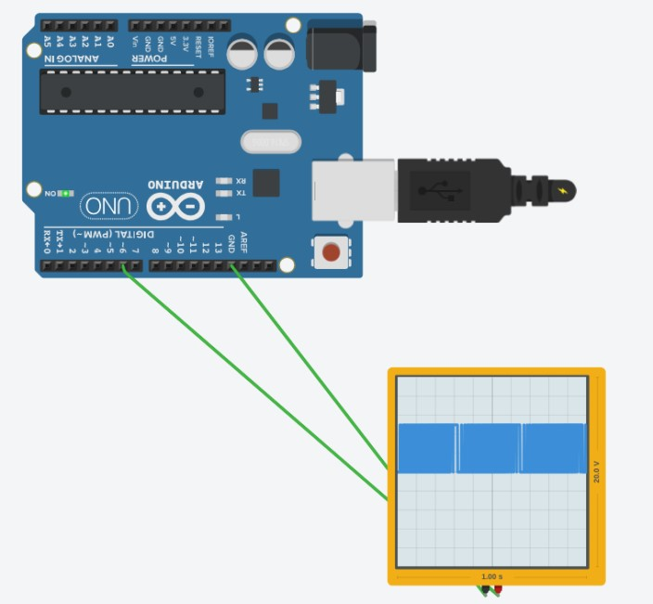

5

}

LAB 08

UART Communication



Spring 2026
Embedded Systems Lab

Submitted By:Naveed Ahmad
Registration No: 22PWCSE2165
Class Section: B

Submitted to:

Engr. Muhammad Shahzad

May 3, 2026

Department of Computer Systems Engineering
University of Engineering and Technology

LAB 08

Universal Asynchronous Reciever Transmitter
It is a hardware communication protocol used for serial data exchange between devices, such as microcontrollers, sensors, GPS modules, and computers.
Asynchronous – No shared clock signal; devices agree on a preset baud rate (e.g., 9600, 115200 bits per second).
Uses two data lines:
TX (transmit) – sends data from one device to another’s RX.
RX (receive) – receives data from another device’s TX.
Data format – A start bit, 5–9 data bits (usually 8), optional parity bit (for error detection), and 1–2 stop bits.
Typical use:
Uploading code to Arduino/ESP32 via USB-UART bridge.
Logging debug messages to a PC terminal (e.g., PuTTY, serial monitor).
Connecting GPS receivers, Bluetooth modules (HC-05), or RFID readers.

KEY CONCEPTS
BUAD RATE:
Definition: The speed at which data is transmitted over a serial link, measured in symbols per second. In UART, one symbol is typically one bit, so baudrate ≈ bits per second (bps).
Examples: 9600, 115200 baud.
Why it matters: Both devices must use the same baudrate (e.g., 9600). If they mismatch, received data will be garbage.
>the longer the distance the smaller the baud rate.
FULL DUPLEX:
Definition: Simultaneous two-way communication. Data can be sent and received at the same time. How UART does it: Uses separate lines – TX (transmit) and RX (receive). Device A’s TX connects to Device B’s RX, and A’s RX connects to B’s TX. This allows both sides to talk without waiting.

REGISTERS:
UBRR (baud rate register
Formula: UBRR=(F_CPU/16*Baud))-1

UCSR0B
RxENO . enable receiver
TxENO . enable transmitter

UCSR0C
Sets data format (8 bit, parity, stop bits)

UBR0
Data register(send/receiver)

TASK1
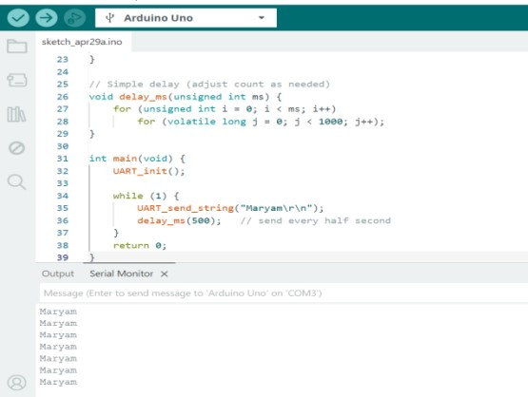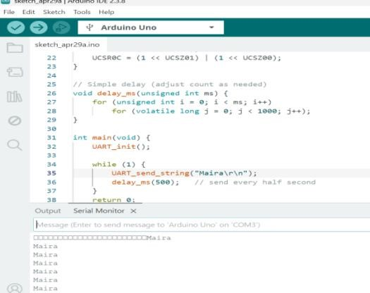
Send your names continuously on UART

TASK2
Create echo system (whatever user types, sends back)
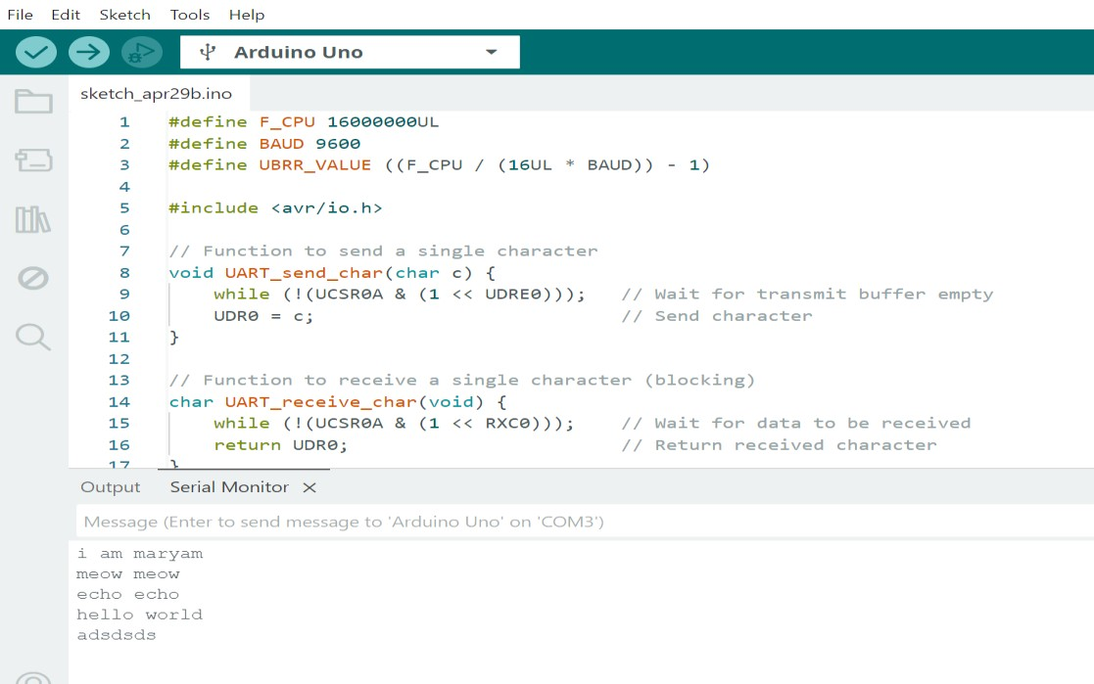

TASK3
Control LED/Buzzer using serial communication 0=off and 1= on
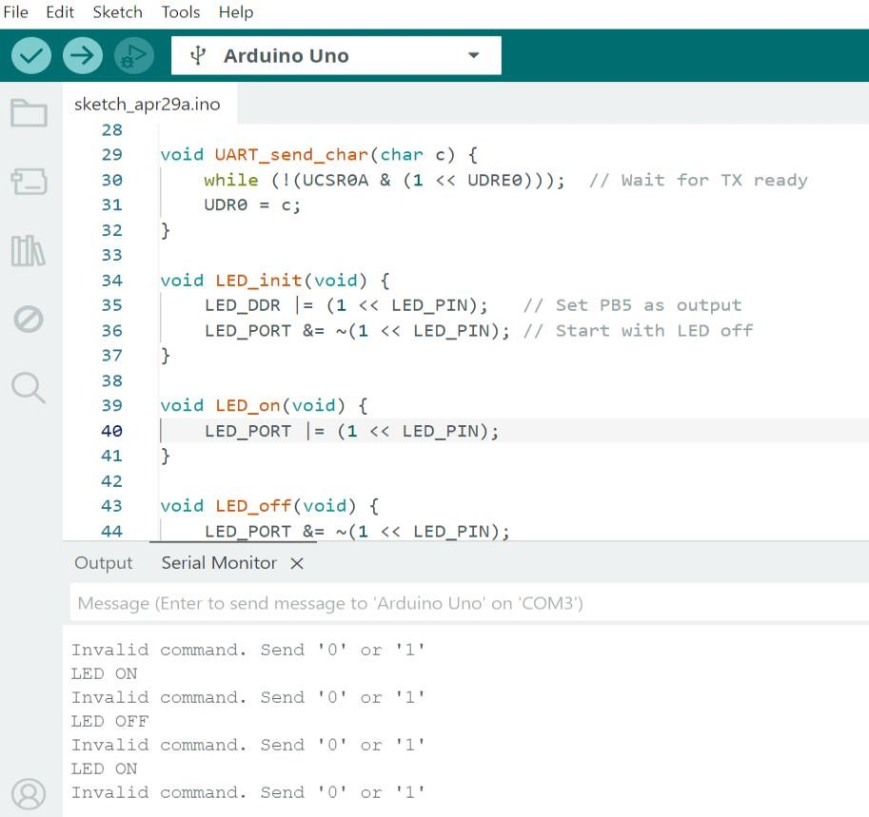
LAB 09

I2C Communication



Spring 2026
Embedded Systems Lab

Submitted By: Naveed Ahmad
Registration No: 22PWCSE2165
Class Section: B

Submitted to:

Engr. Muhammad Shahzad

June 25, 2026

Department of Computer Systems Engineering
University of Engineering and Technology

LAB 09

I2C COMMUNICATION (inter-integrated service)
I2C is a simple, low-speed, two-wire serial communication protocol used to connect multiple microcontrollers, sensors, displays, memory chips, and other peripherals on the same circuit board. Think of it as a bus where all devices share the same two wires.

The Two Essential Wires
Wire Name Purpose
SDA (Serial Data Line) Carries the actual data being sent (bi-directional).
SCL (Serial Clock Line) Carries the clock signal generated by the master to synchronize data transfer.
Pull-up resistors are required on both wires (typically 4.7kΩ) to pull the lines to a logic high when no device is driving them.
How I2C Works (Master-Slave)
I2C uses a Master/Slave architecture.
Master: The device that controls the clock (SCL) and initiates all communication. (e.g., a microcontroller).
Slave: A peripheral device that waits for commands from the master. (e.g., temperature sensor)
Key feature: Every slave device has a unique 7-bit or 10-bit address. The master uses this address to talk to a specific slave.
Working: Every device has a unique address(like our reg.no), Send a start signal, broadcast the address, says read\write, the matching device responds, sends a stop signals

Pros vs. Cons
Pros | Cons
Only 2 wires (SDA, SCL) for many devices | Slower than SPI (typically 100kbps, 400kbps, or 3.4Mbps)
Multi-master & Multi-slave support | Requires pull-up resistors, limiting cable length
Simple addressing – no chip-select pins | Devices share the bus, so collisions are possible
ACK/NACK handshake for error checking | Power consumption higher than SPI due to pull-ups
Uses
Reading temperature/humidity sensors (e.g., BME280, AHT20)
Communicating with OLED/LCD displays (SSD1306)
Interfacing with real-time clocks (DS3231)
Reading EEPROM memory chips (24LCxx)
Connecting multiple Arduinos or micro:bits

HALF-DUPLEX COMMUNICATION

TASK 01:
- Scan I2C bus (find connected device). write a program that checks all 7-bit I2C adresses (0-127)
- For each address .>send start, >send address ,>check for ACK
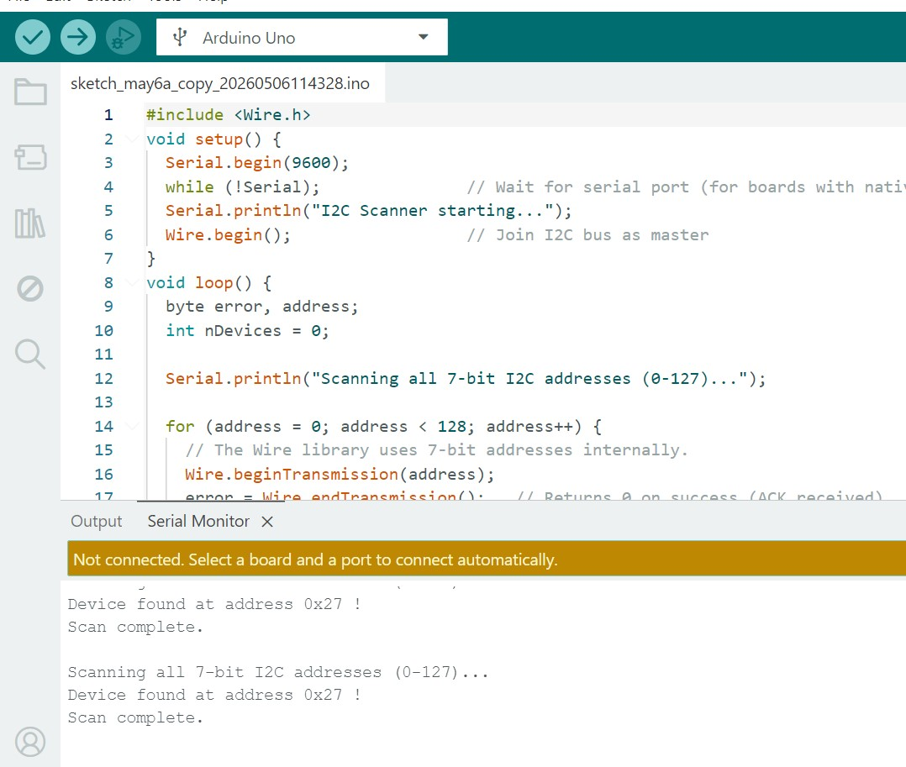

TASK 2
- Master writes data to slave 2x Arduino
•
MASTER WRITES
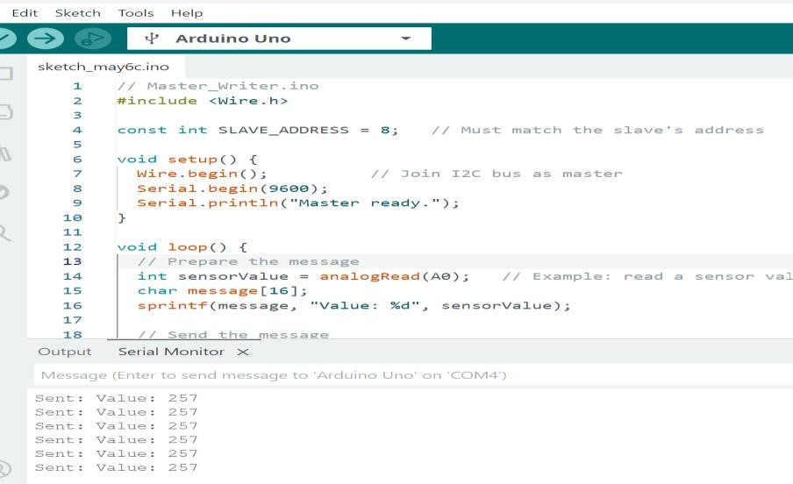

SLAVE RECEIVES
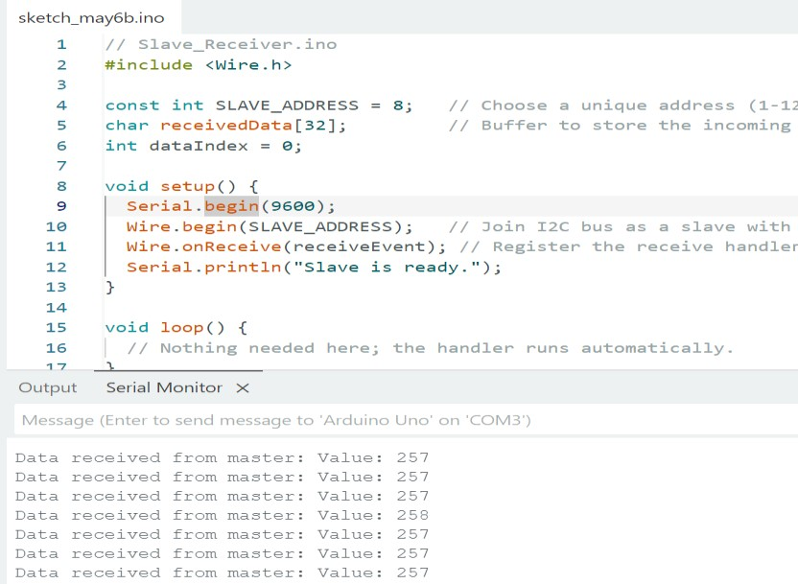

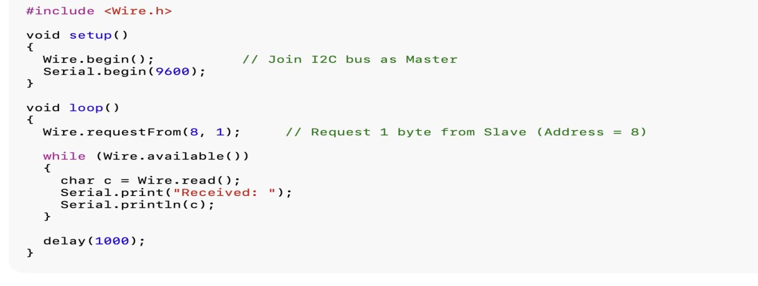
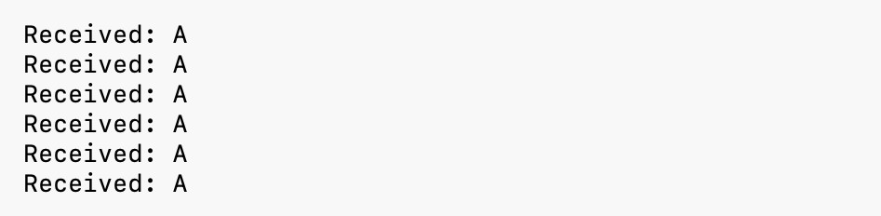
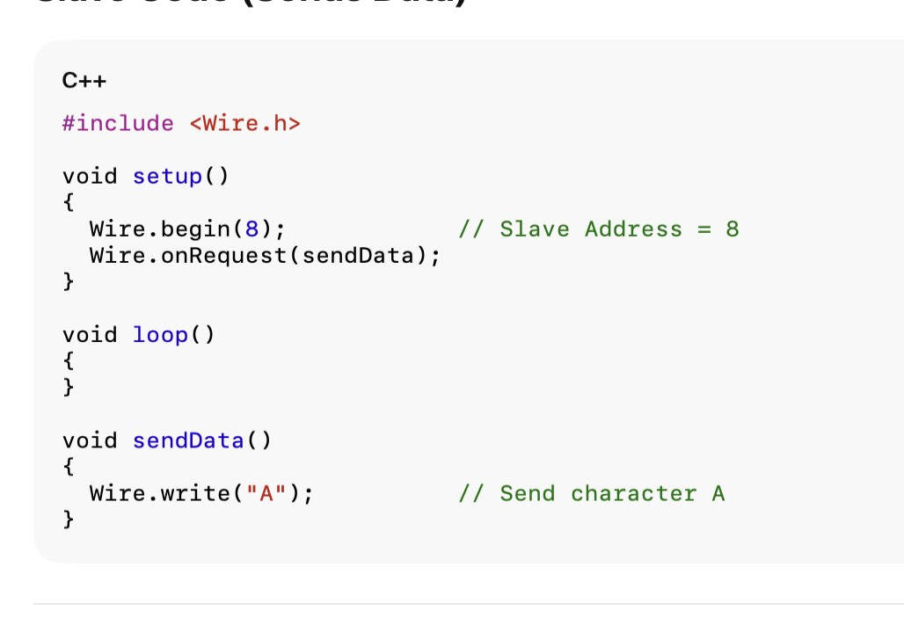

TASK 03:

Master reads data from slave

Master
Reads :

:

Slave Write:

LAB 10

SPI Communication



Spring 2026
Embedded Systems Lab

Submitted By: Naveed Ahmad
Registration No: 22PWCSE2165
Class Section: B

Submitted to:

Engr. Muhammad Shahzad

June 25, 2026

Department of Computer Systems Engineering
University of Engineering and Technology

LAB 10

SPI COMMUNICATION
SPI (Serial Peripheral Interface) communication is a synchronous serial communication protocol used to transfer data between a microcontroller (master) and one or more peripheral devices (slaves) like sensors, displays, memory chips, etc.
Key Features
- Full-duplex: Data can be sent and received at the same time
- High speed: Faster than protocols like I²C
- Simple hardware: Uses a few dedicated lines SPI Lines (Signals)
SPI typically uses 4 wires:
- MOSI (Master Out Slave In) : Data sent from master → slave
- MISO (Master In Slave Out) : Data sent from slave → master
- SCLK (Serial Clock) : Clock signal generated by the master to synchronize data
- SS / CS (Slave Select / Chip Select) : Used by the master to select which slave device to communicate with
TASK 01:
- Basic data transfer (loop back test) connect MOSI and MISO for arduino uno
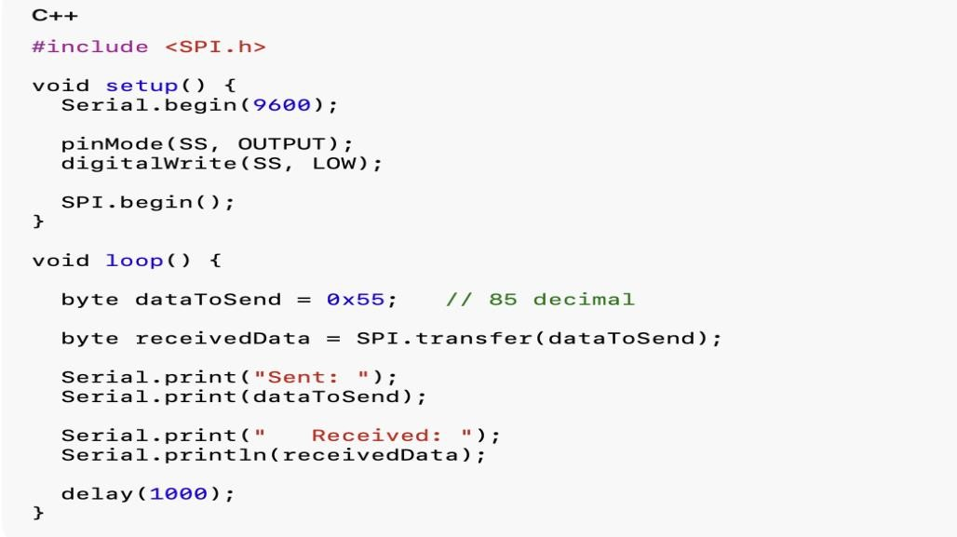
OUTPUT:
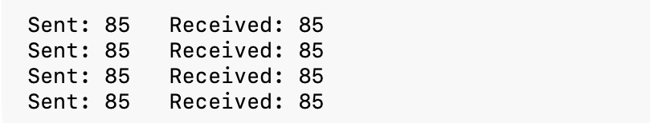

TASK 02
- Master sends data to slave. need two arduinos

Master Code

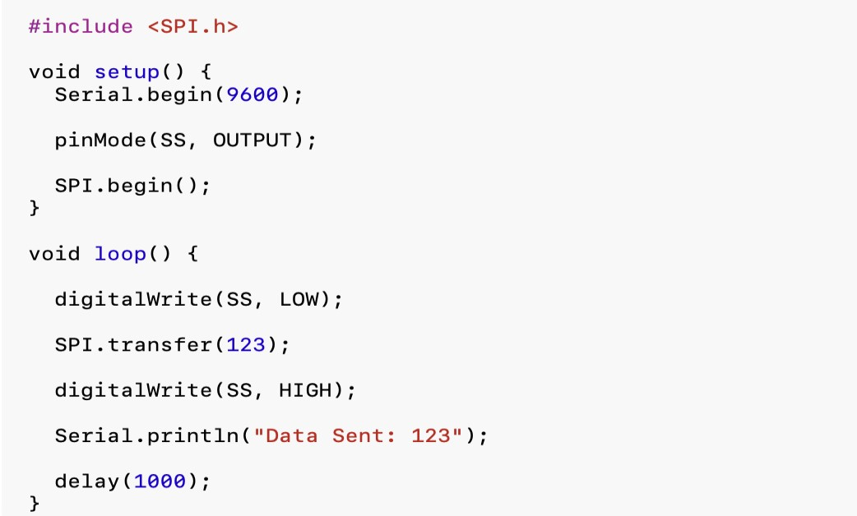

Slave Code:

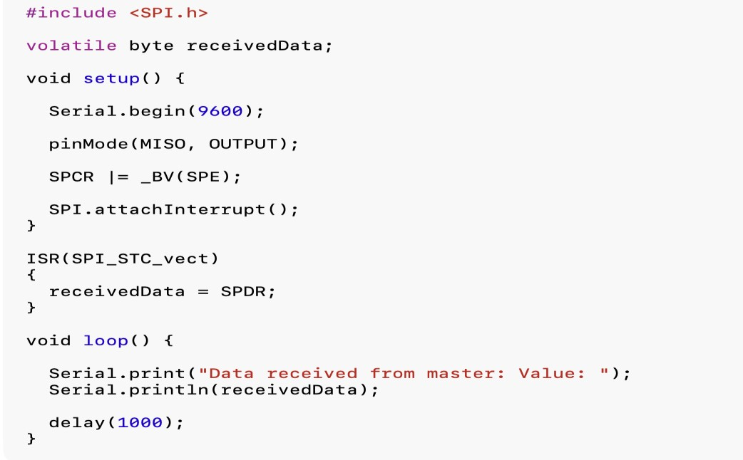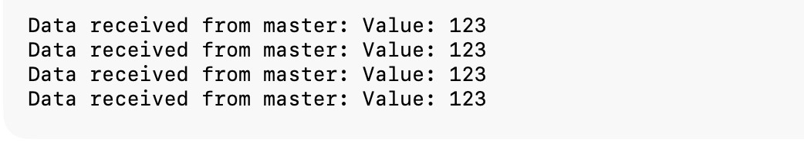

TASK 03

• Master Reads Data from Slave

Master Code

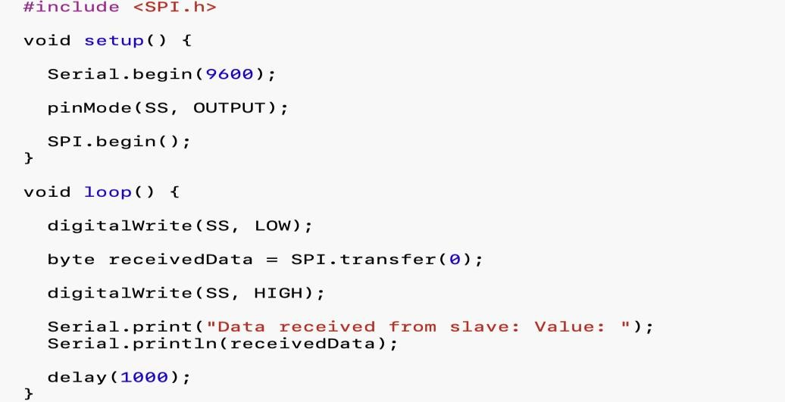
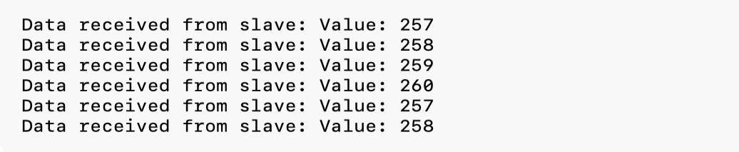

Slave Code
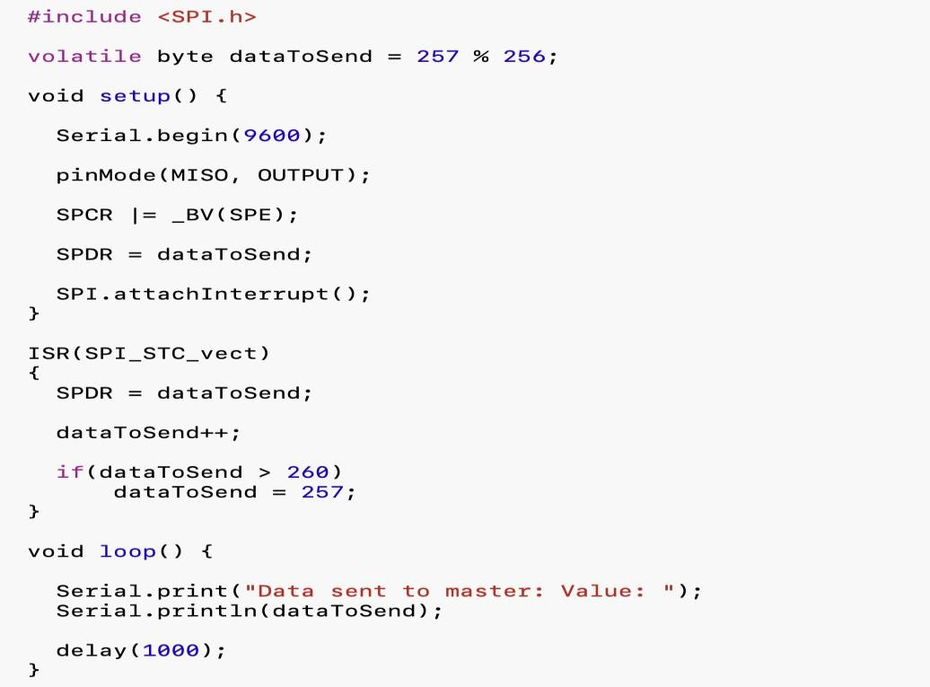

LAB REPORT NO 11

Power Management


Spring 2026
CSE-420L Embedded Systems LAB

Submitted By: Naveed Ahmad
Registration No: 22PWCSE2165

Section: B

“On my honor, as student of University of Engineering and Technology, I have neither given nor received unauthorized assistance on this academic work”

Submitted to:

Engr. Muhammad Shahzad
June 25, 2026

Department of Computer Systems Engineering
University of Engineering and Technology Peshawar

Title: Power Management
Objective:
The objective of this lab is to study different power management techniques in embedded systems using the ATmega328P microcontroller. The lab focuses on reducing power consumption by using sleep modes, timer interrupts, and disabling unused peripherals.

Class lecture:
MC’s Consumes power mainly in
- CPU operation
- Clock system
- GPIO switching
- Communication peripherals
- ADC/DAC Modules
- Timers

Power Consumption depends upon
- Clock frequency
- Supply voltage
- Number of enable peripherals
- CPU

Mode:
- Active mode → CPU and Peripheral fully active ➢ Idle mode → CPU stops but peripherals running.
- Sleep Mode → Most internal modes disabled ➢ Power Down mode → Almost everything turned off.
- Standby mode → lowest power mode with quick wakeup.

Sleep Mode:
- CPU clock is stopped.
- Program execution power.
- Power consumption is very low.
- External interrupt can wakeup MCV.

Register Used (ATmega328p):
- SMCR → Sleep mode control Register
Bit Name
SE Sleep enable
SM Sleep mode select

- MCUCR → MCU control register.
-Used for interrupt trigging configuration.
- EIMSK → External Interrupt mask Register -Used to enable external interrupts.
- EIFR → External interrupt flag Register.
-Stores interrupt flags.

Power Reduction Registers --PRR
BIT Peripheral
PRADC ADC

Apparatus:
- Arduino Uno / ATmega328P Microcontroller
- Push Button
- Breadboard
- LED
- Resistors
- Jumper Wires
- USB Cable
- Computer with Arduino IDE
Theory:
Power management is an important part of embedded systems because microcontrollers consume power during CPU processing, clock operation, GPIO switching, timers, communication modules, and ADC/DAC operations. Reducing power consumption increases battery life and improves system efficiency.
The ATmega328P provides different power-saving modes such as:
- Active Mode: CPU and peripherals remain fully active.
- Idle Mode: CPU stops working but peripherals continue running.
- Sleep Mode: Most internal modules are disabled to save power.
- Power Down Mode: Almost all internal circuits are turned off.
- Standby Mode: Lowest power mode with fast wake-up capability.
Important registers used in power management are:
- SMCR: Controls sleep modes.
- MCUCR: Configures interrupts.
- EIMSK: Enables external interrupts.
- EIFR: Stores interrupt flags.
- PRR: Disables unused peripherals to save power.

Task01:
Basic sleep mode
Put MC into sleep mode and wake it up using external interrupt.
(Sleep mode power down)

Procedure:
- Build the circuit on breadboard.
- Upload the code to Arduino Uno.
- Observe that the MCU enters sleep mode.
- Press the push button to generate interrupt.
- MCU wakes up and LED operation resumes.
Circuit Diagram and output:
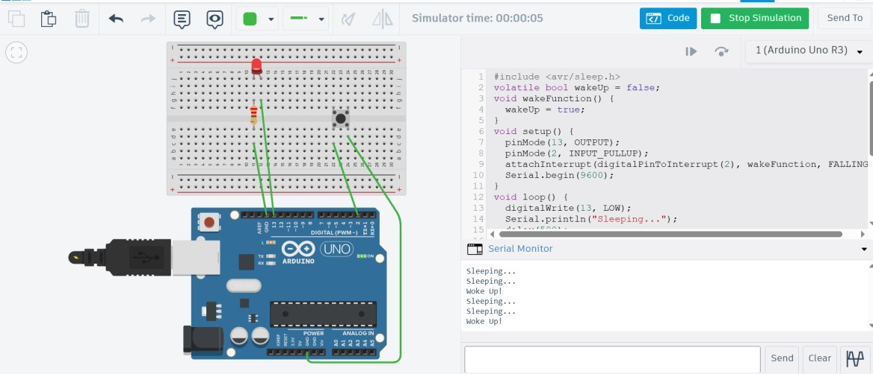
Connections:
- LED connected to digital pin 13.
- Push button connected to interrupt pin.
- Ground and VCC connected properly.
Code:
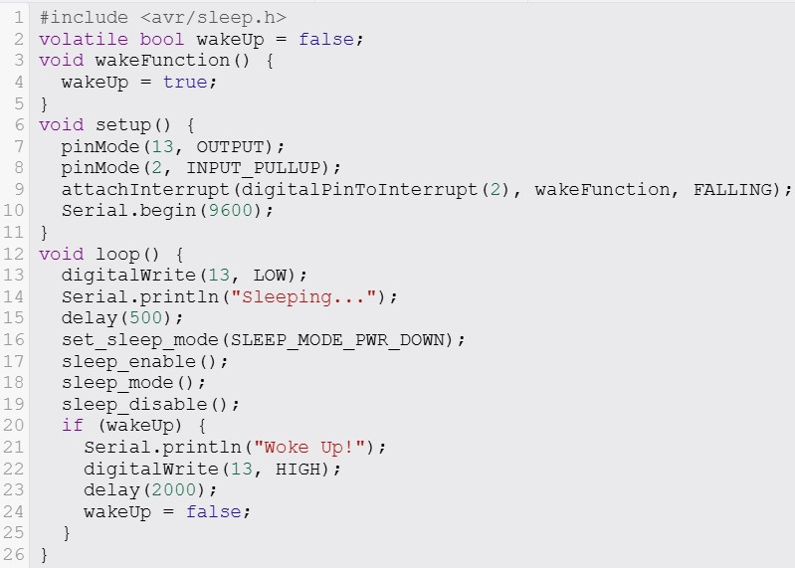
Algorithm:
- Initialize the microcontroller.
- Configure sleep mode as power-down mode.
- Put the MCU into sleep mode.
- Wait for external interrupt from push button.
- Wake up the MCU and continue execution.
Result:
The microcontroller successfully entered sleep mode and woke up through an external interrupt, reducing power consumption during inactive time.

Task 02:
Timer Based wakeup
Wake-up the MCU periodically using timer interrupts.
(Sleep mode Idle)

Procedure:
- Connect the circuit and upload the code.
- Configure Timer1 interrupt in the program.
- Observe the MCU entering idle sleep mode.
- Timer interrupt wakes up MCU repeatedly.
- LED blinks periodically after each wake-up.
Circuit Diagram and output:
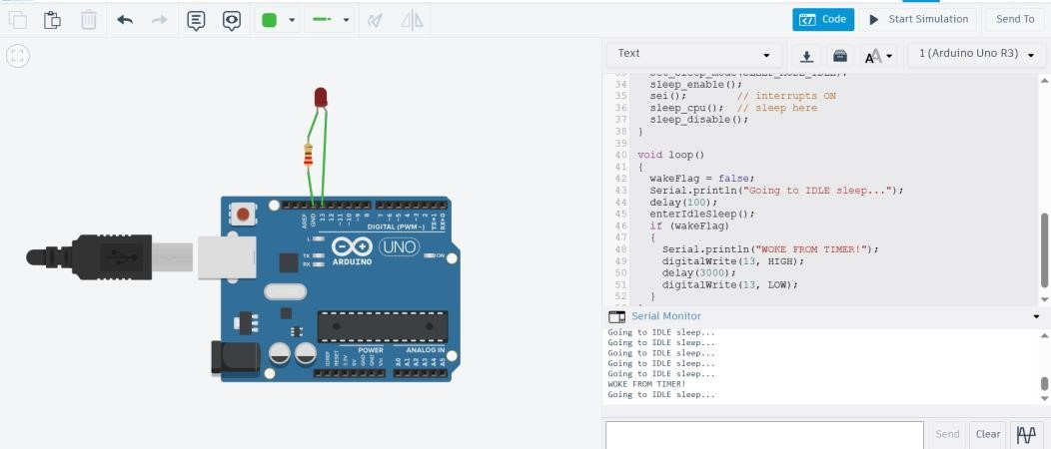
Connections:
- LED connected to pin 13.
- Timer interrupt configured internally.
- Power connections provided to Arduino board.
Code:
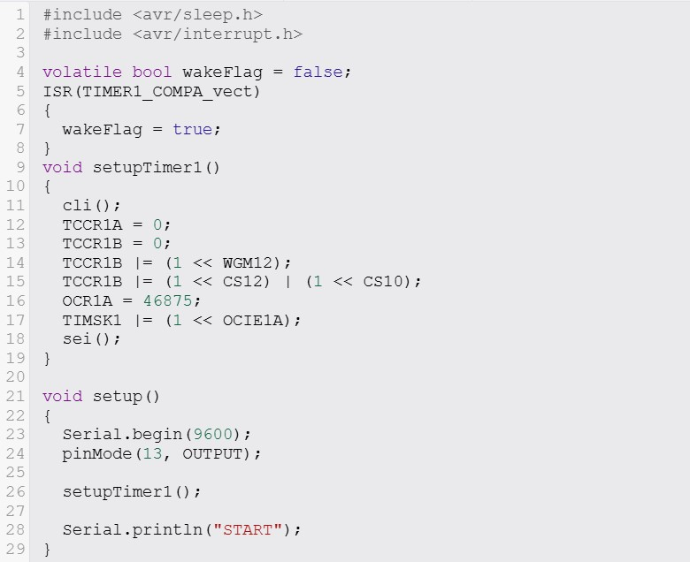
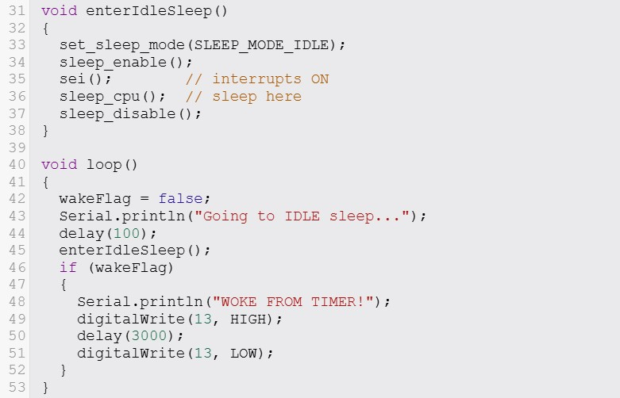
Algorithm:
- Configure Timer1 interrupt.
- Set sleep mode to idle mode.
- Put MCU into sleep mode.
- Timer interrupt occurs after a fixed interval.
- MCU wakes up periodically and performs tasks.
Result:
The timer interrupt successfully woke the MCU at regular intervals while the system remained in low-power idle mode.

Task 03:
Peripheral power saving
Reduce the power consumption by disabling unused peripherals. Unused peripherals still use power Example:
ADC | ADC disable
SPI
I2C  Timers | ADCSRA &=~(1<<ADEN); // Disable
UART | ADCSRA |=(1<<ADEN); // Enable

Procedure:
- Upload the program to Arduino board.
- Disable unused peripherals in code.
- Observe reduced activity of modules.
- Re-enable peripherals when needed.
- Compare power-saving behavior.

Circuit Diagram and output:
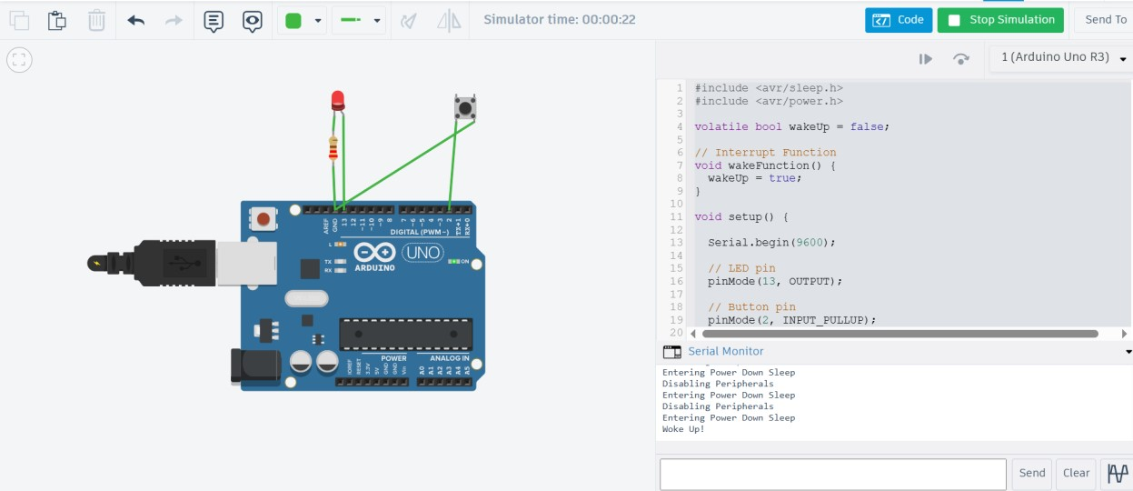

Connections:
- Arduino Uno connected normally.
- LED connected for output indication.

Code:

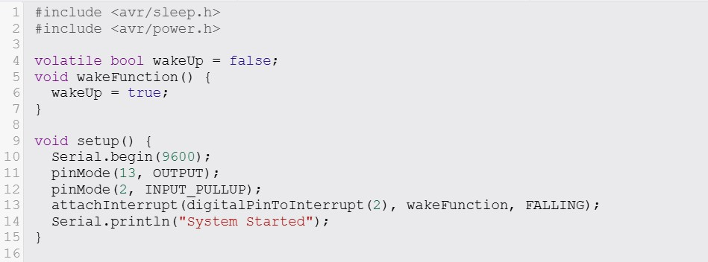

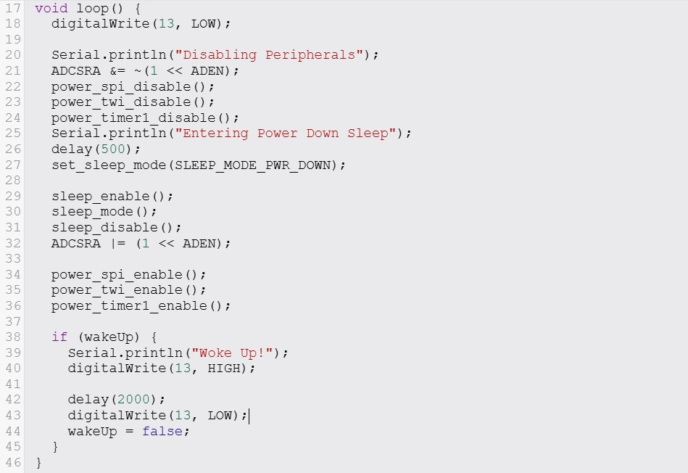

Algorithm:
- Identify unused peripherals.
- Disable unused modules such as ADC, SPI, I2C, UART, and Timers.
- Run the system with reduced peripherals.
- Enable peripherals again when required.

Result:
Power consumption was reduced successfully by disabling unused peripherals, improving the efficiency of the embedded system.

Conclusion:
In this lab, different power management techniques of the ATmega328P were studied successfully. Sleep modes, timer interrupts, and peripheral disabling methods helped reduce power consumption effectively. The lab showed how embedded systems can save energy and improve battery performance by using proper power management techniques.

________________________________END_____________________________

LAB REPORT NO 12

ROTS (Real-Time Operating System)


Spring 2026
CSE-420L Embedded Systems LAB

Submitted By: Naveed Ahmad
Registration No: 22PWCSE2165

Section: B

“On my honor, as student of University of Engineering and Technology, I have neither given nor received unauthorized assistance on this academic work”

Submitted to:

Engr. Muhammad Shahzad
June 25, 2026

Department of Computer Systems Engineering

University of Engineering and Technology Peshawar

Title: ROTS (Real-Time Operating System)

Objectives
The objective of this lab was to understand the basic concepts of Real-Time Operating Systems (RTOS) and implement multitasking using FreeRTOS on embedded systems. The lab focused on task creation, task scheduling, multitasking, LED control, serial communication, and task priority handling.

Apparatus:
- ESP32 Board
- LEDs
- Resistors
- Jumper Wires
- Breadboard
- USB Cable
- Wokwi software
- Arduino IDE with FreeRTOS Library

Lecture:
Real time operating systems An Operating system designed to execute tasks with precise timing constraints.
→Unlike windows/ Linux focus on user experience.
→RTOS focuses on deterministic timing.

RTOS Ensure:
- Fast Response
- Predicted execution
- Task prioritization
- Multitasking

Types:
- Hard Real-time
Missing deadline = system failure
Ex:
o Aircraft control o Medical device o Missile system

- Soft Real-time
Missing deadline reduces performance but system still works.
EX:
o Video streaming o Gaming o Drone telemetry display
Problems:
- No priority handling.
- Blocking delays stops.
- Difficult to scale
- Timing become

ROTS Solves this by
- Resuming multiple tasks independently
- Scheduling tasks efficiently
- Managing priorities
- Reducing CPU wastage

RTOS Concepts:
Tasks: A small independent program
Ex:
- LED blinking
- Sensor Reading
- UART Communication
- Motor Control

Schedules:
- Decides which task runs
- When it runs.
- For how long
Priority:
Higher priority tasks run before low priority tasks.
Ex:
Emerging stop button → High priority.

LCD update → Low priority
Context switching:
RTOS saves the state of one task and switched to another.
- Register
- Program counter
- Stack pointer
Free RTOS |  | Most common in embedded system
Zephyr |  | IOT Application
RTX |  | Arm Complex System
VxWorks |  | Aerospace and defense
RTEMS |  | Space System

Free RTOS Basics:
Components
Tasks: Impendent functions executed by scheduler
Queues: Used for task communication
Semaphores: Used for synchronization
Timers: Execute functions periodically

Tasks States:
Running: Currently executing
Ready: Waiting for CPU
Blocked: Waiting for event or delay Suspended: Temporary stopped
Theory
A Real-Time Operating System (RTOS) is an operating system designed to perform tasks within a specific time limit. Unlike normal operating systems that focus on user experience, RTOS focuses on fast and predictable task execution.
RTOS provides:
- Fast response time
- Multitasking
- Task scheduling
- Task prioritization
- Efficient CPU usage
In FreeRTOS, tasks run independently and the scheduler decides which task should execute according to its priority. Higher priority tasks execute before lower priority tasks. RTOS also supports context switching, where the CPU switches from one task to another efficiently.
Main RTOS Components:
- Tasks
- Queues
- Semaphores
- Timers

Task01:
Basic RTOS Program 2 –task running independently Concept:
Task1: Led blinking
Task2: Print message on serial Monitor.

- XtaskCraete( TasksFunction, )
Procedure:
- Connect the circuit properly.
- Open Arduino IDE.
- Write and upload the code.
- Open Serial Monitor.
- Observe LED blinking and serial messages simultaneously.

Code:
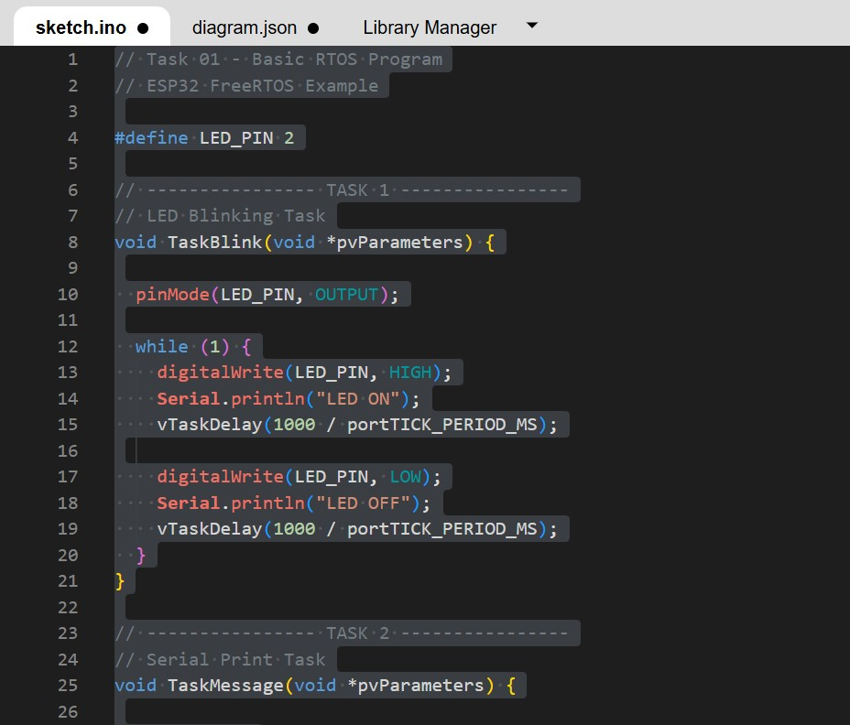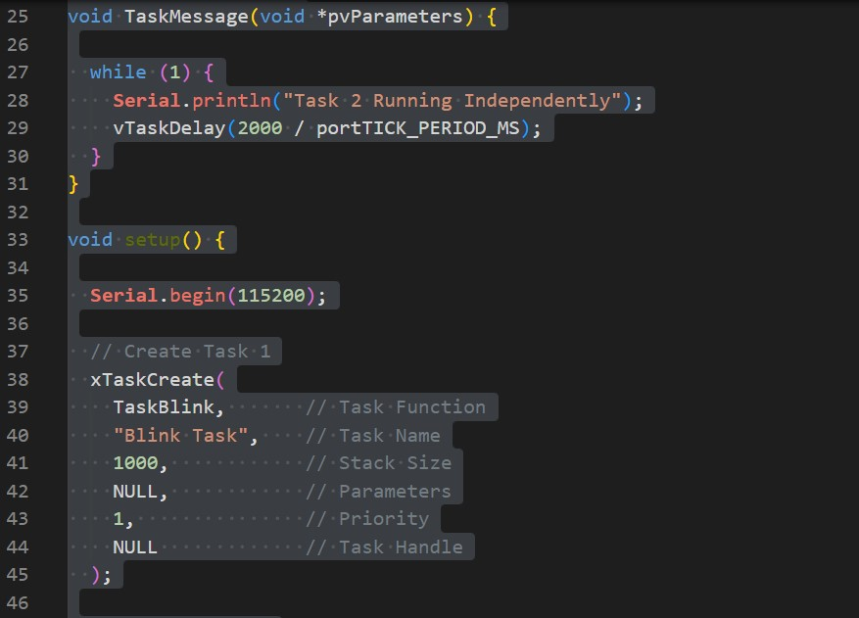

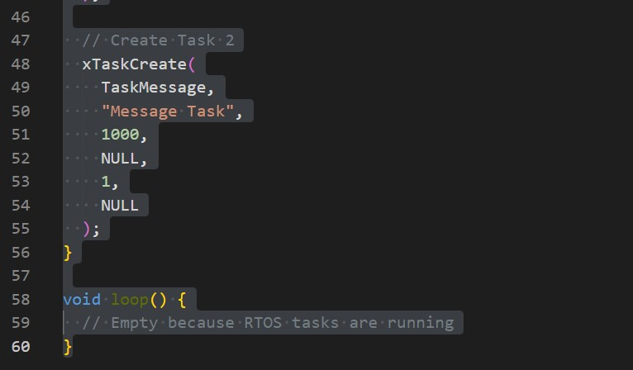

Connections:
- Connect one LED to a digital output pin through a resistor.
- Connect the board to the computer using a USB cable.
- Open Serial Monitor for message display.

Circuit Diagram and Output:
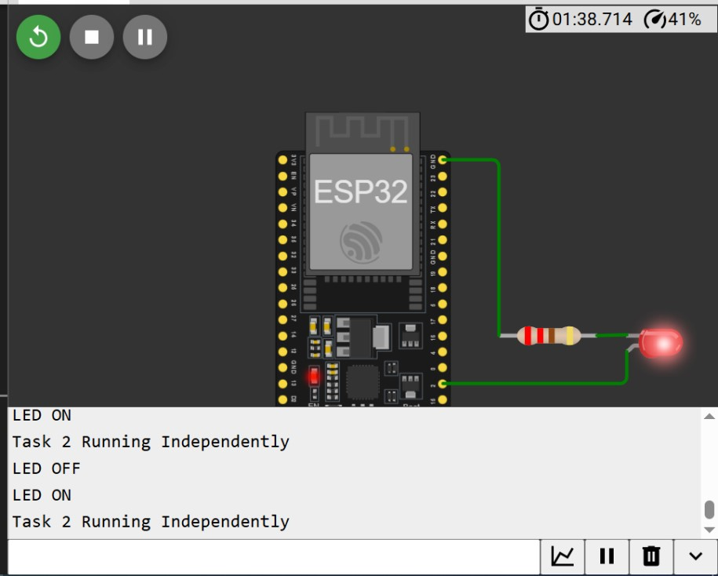

Algorithm:
- Start the program.
- Create Task 1 for LED blinking.
- Create Task 2 for printing messages on Serial Monitor.
- Start the scheduler.
- Both tasks run independently in parallel.
Result:
The LED blinked continuously while messages were printed on the Serial Monitor at the same time. This showed successful multitasking using RTOS.
------------------------------------------------------------------------
Task 02:
Dual LED Control Create 2 tasks
1 Control LED1 (500 ms)
2nd Control LED2 (1000 ms)

Tasks Priority:
xTaskCreate(Task1, “low”, 1000, Null, 1, Null) xTaskCreate(Task2, “High”, 1000, Null, 3, Null) Procedure:
- Make the LED connections on breadboard.
- Open Arduino IDE and write the program.
- Upload the code to the board.
- Observe the blinking pattern of both LEDs.
Code:
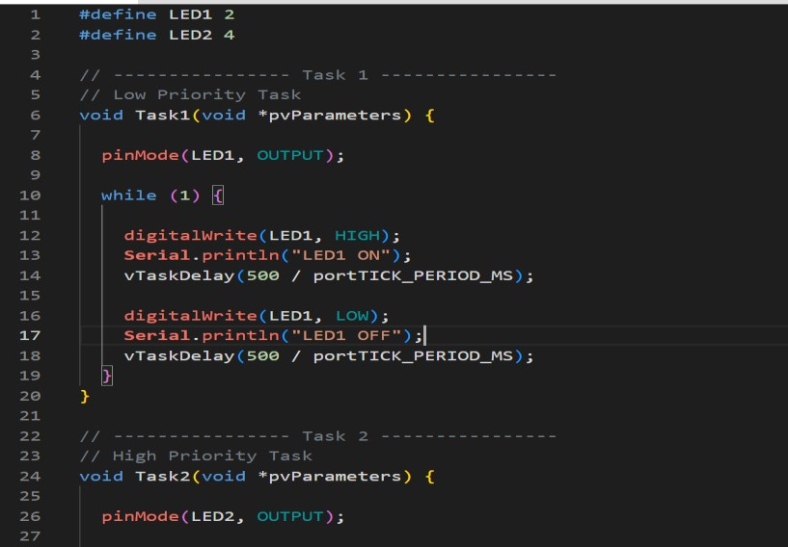
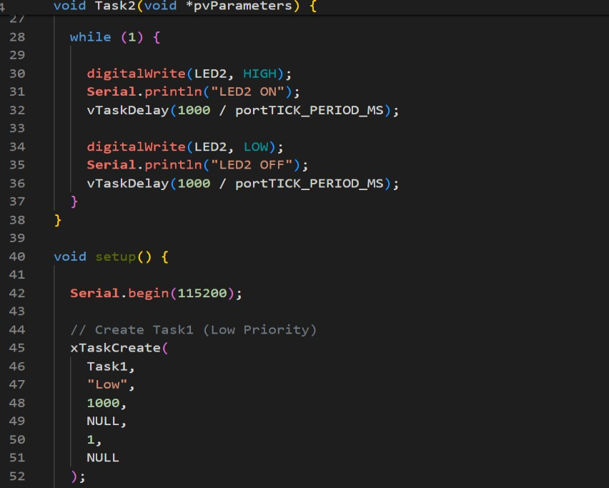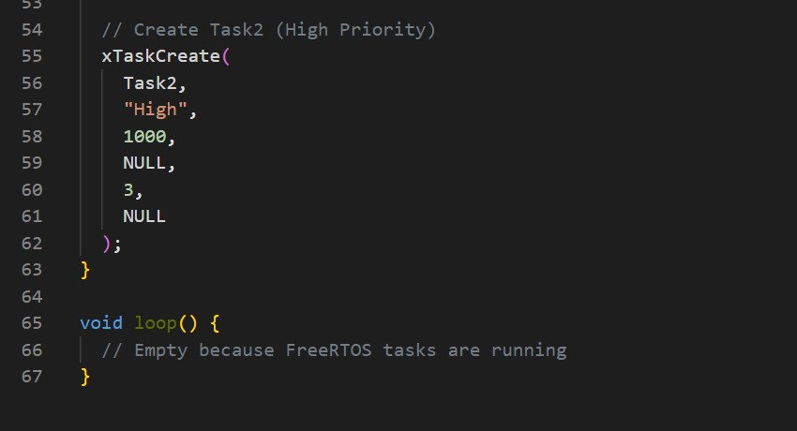

Circuit diagram and Output:
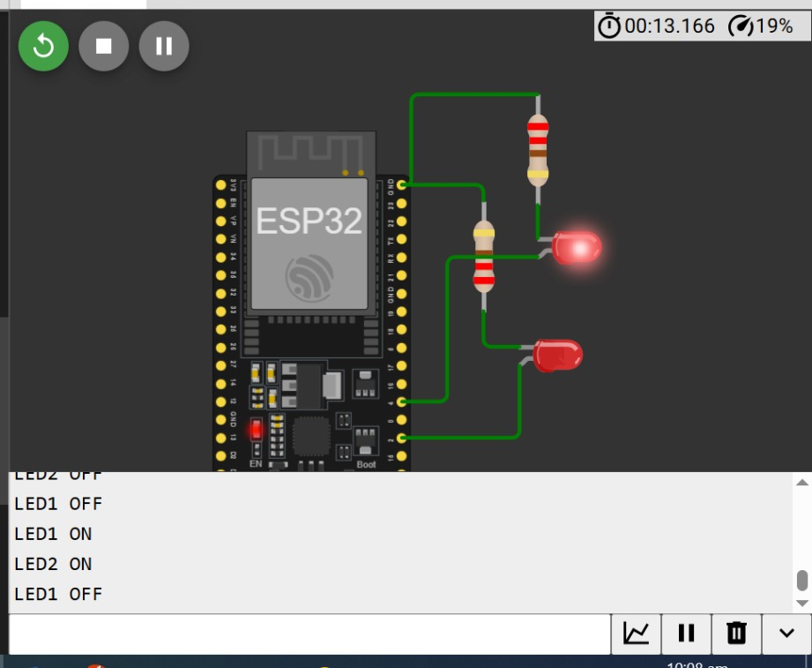
Connections:
- Connect LED1 to pin 13 through a resistor.
- Connect LED2 to pin 12 through a resistor.
- Connect the board to the computer using USB cable.

Algorithm:
- Initialize both LED pins as outputs.
- Create Task 1 for LED1 blinking every 500 ms.
- Create Task 2 for LED2 blinking every 1000 ms.
- Assign different priorities to tasks.
- Start the scheduler.
- Both LEDs blink independently.

Result
LED1 blinked every 500 ms while LED2 blinked every 1000 ms. Both tasks executed independently with different priorities.
--------------------------------------------------------------

Task 03:
Task Priority demonstration.
Create:
High priority task
Low priority task

High Priority task execute more often.

Procedure:
- Open Arduino IDE.
- Write the program for task priorities.
- Upload the code.
- Open Serial Monitor.
- Observe task execution frequency.

Code:
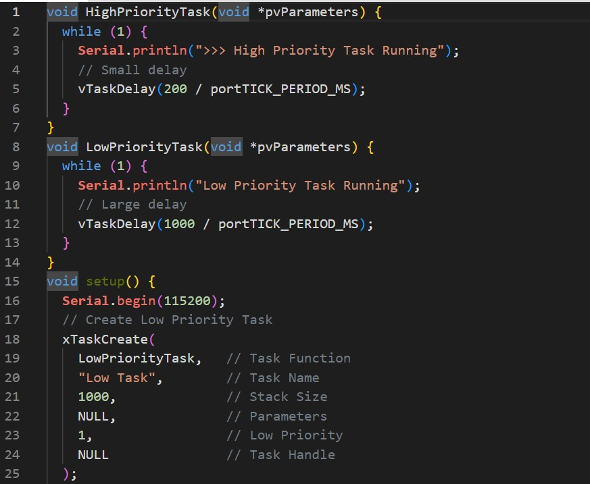

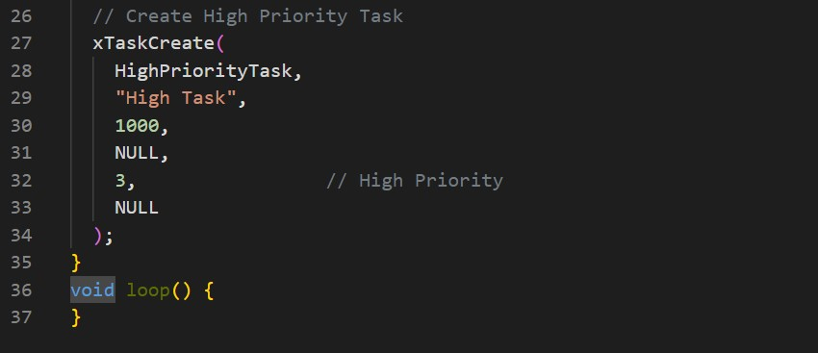

Circuit and Output:
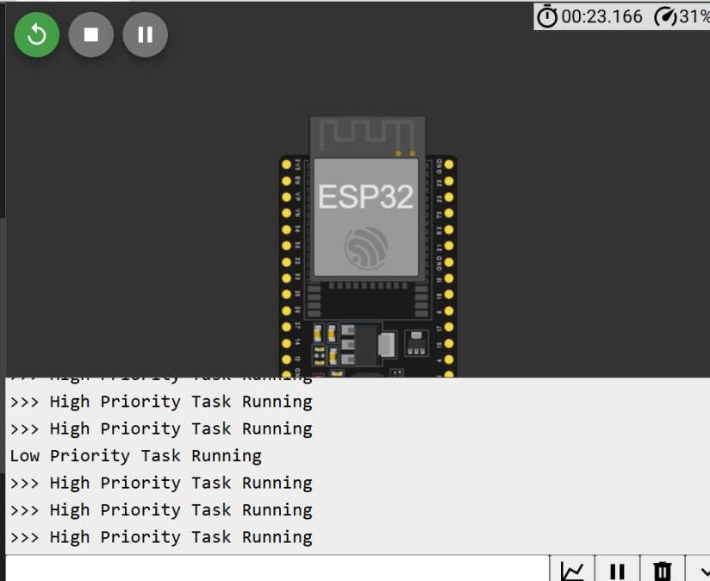

Connections:
- Connect the board to the computer using USB cable.
- Use Serial Monitor to display task execution.

Algorithm:
- Create a high priority task.
- Create a low priority task.
- Print messages from both tasks.
- Assign higher priority to one task.
- Start scheduler.
- Observe execution behavior.

Result:
The high priority task executed more frequently than the low priority task. This demonstrated how RTOS handles task priorities efficiently.
Conclusion:
In this lab, we learned the fundamentals of RTOS and FreeRTOS. Different tasks were created and executed independently using multitasking. We also learned task scheduling, task priorities, and efficient CPU management in embedded systems. The lab successfully demonstrated how RTOS improves system performance and responsiveness.

________________________________END_____________________________

